Moduldokumentation

Modul Verteilte Systeme (vesys)

Simon Wächter

2017

Inhalt

1 Einleitung 4

1.1 Einleitung 4

1.2 Lernziele 4

1.3 Prüfungen 4

2 Woche 1 5

2.1 Definition of Distributed Systems 5

2.1.1 Definitions 5

2.1.2 Classification 5

2.1.3 Pros and Cons 6

2.1.4 Interaction Models 6

2.1.5 Client/Server Model 7

2.1.6 Communication Models 7

2.1.7 Communication Styles 8

2.2 Challenges of Distributed Systems 9

2.2.1 Heterogeneity 9

2.2.2 Latency 9

2.2.3 Security 9

2.2.4 Scalability 10

2.2.5 Failures 10

2.2.6 Concurrency 11

2.2.7 Consistency 11

2.3 Networking 11

2.3.1 Protocol & Network Levels 11

2.3.2 IP Socket Connections 12

2.3.3 IP Addressing 12

2.3.4 TCP/UDP Common Port Numbers 13

2.3.5 InetAddress 13

2.3.6 Network Interfaces 14

2.4 Sockets 14

2.4.1 Sockets 14

2.4.2 TCP Sockets 15

2.4.3 Java Socket 15

2.4.4 Sample Client (Echo) 17

2.4.5 Sample Client (Mailer) 17

2.4.6 ServerSocket 18

2.4.7 Echo Server 19

2.4.8 Concurrent Echo Server 19

2.4.9 Concurrent Echo Server (Threaded) 19

2.4.10 Concurrent Echo Server (Limitierter Threadpool) 20

2.4.11 Concurrent Echo Server (Dynamischer Threadpool) 21

3 Woche 2 23

3.1 Input and Output Streams 23

3.1.1 OutputStream 23

3.1.2 InputStream 23

3.2 Filter Streams 24

3.2.1 FilterOutputStream 24

3.2.2 DataOutputStream 25

3.2.3 DataOutputStream with writeInt 25

3.2.4 DataOutputStream with writeUTF 25

3.2.5 PrintStream 26

3.2.6 FilterInputStream 26

3.2.7 DataInputStream 26

3.2.8 DataInputStream with readFully 27

3.2.9 Filter Streams 27

3.3 Object Streams & Serialization 27

3.3.1 ObjectStream 27

3.3.2 Serialization with ObjectStream 28

3.3.3 Serial Version Number 29

3.3.4 Serialization Customization 30

3.3.5 Serialization Hints 30

3.4 Sending and Receiving Data 31

3.4.1 Framing 31

3.4.2 Example of Framing 31

3.5 Summary 31

3.5.1 Whole Picture of Input Streams 31

3.5.2 Whole Picture of Output Streams 32

3.5.3 Reading and Writing Text (Unicode Strings) 33

3.5.4 Whole Picture of Reader 33

3.5.5 Whole Picture of Writer 33

3.6 Controlling Socket Behaviors 34

3.6.1 Blocking and Timeouts 34

3.6.2 Send and Receive Buffer Size 35

3.6.3 Package Delay 35

3.7 Closing Connections 35

3.7.1 Closing Connections 35

3.7.2 Example of a Close Test 36

3.7.3 Example of a Compression Server 37

3.8 UDP Sockets 37

3.8.1 UDP (User Datagram Protocol) 37

3.8.2 Java Classes for Datagram 38

3.8.3 DatagramSocket 38

3.8.4 DatagramPacket 39

3.8.5 Example of a UDP Server and Client 40

3.8.6 UDP Implementation 40

3.8.7 Reliable UDP 41

4 Woche 3 42

# Einleitung

## Einleitung

Dieses Dokument stellt die Moduldokumentation für das Modul vesys dar. Allfällige Unterlagen sind im Modulordner zu finden.

## Lernziele

Das Modul beinhaltet folgende Lernziele:

* Erstellen einer Verbindung zwischen zwei Rechnern mittels Sockets
* Wissen über http Protokoll und Webserver
* Implementieren einfacher Servlets
* Prinzipien und Programmierung von RMI
* Prinzipien von Webservices und Programmierung mittels JAXWS
* Verwendung von Webservices mittels WSDL
* Prinzipien und Programmierung von REST und deren Unterschiede zu SOA und ROA
* Prinzipien der asynchronen Programmierung mittels JMS und Akka
* Entscheidung, welche der Technologien für eine Situation geeignet ist

## Prüfungen

Die Modulnote setzt sich aus einer Semesterprüfung zu 50% und einer Modulschlussprüfung zu 50% zusammen. Zusätzlich müssen 4 von 8 Übungen erfüllt werden.

# Woche 1

## Definition of Distributed Systems

### Definitions

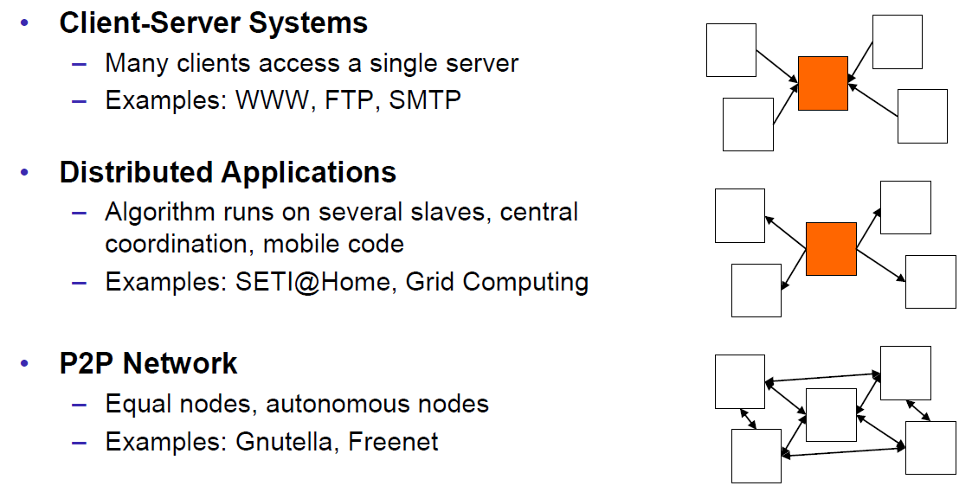

### Classification

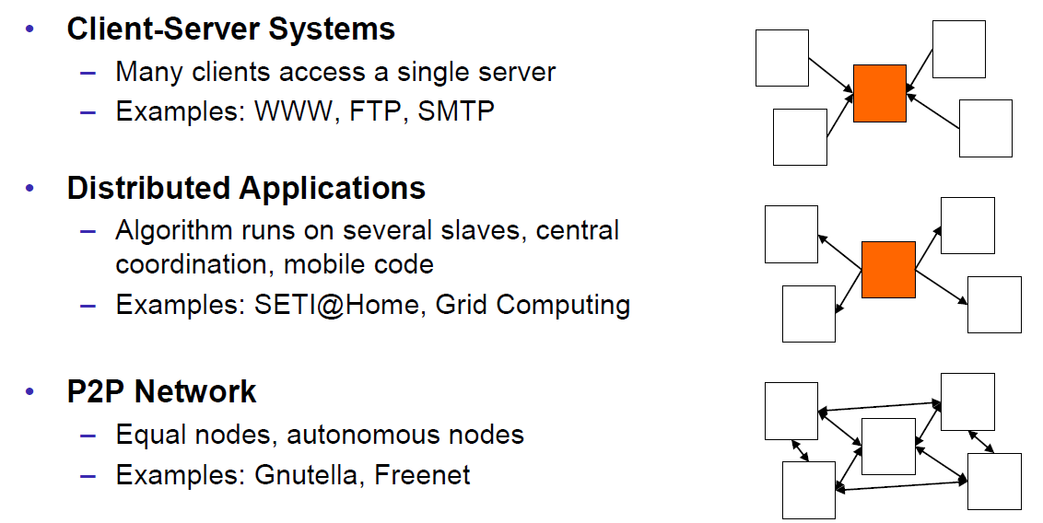

### Pros and Cons

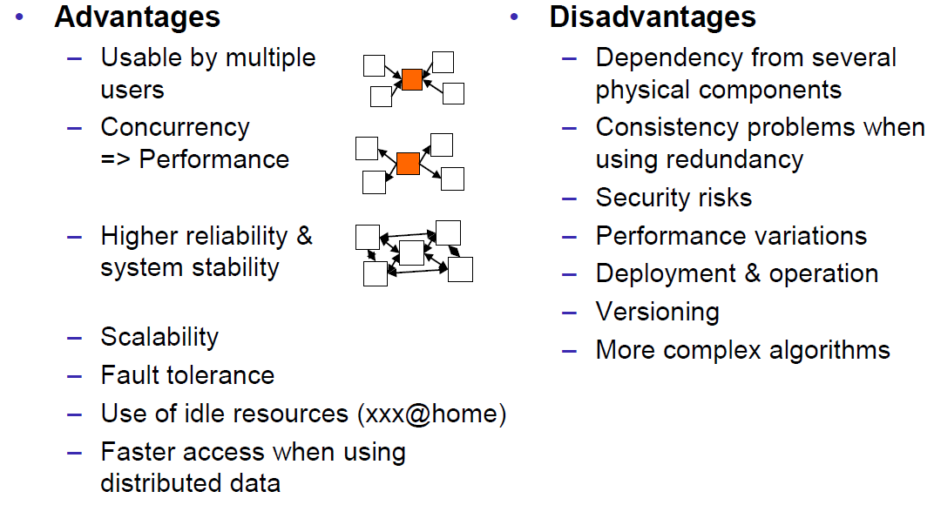

### Interaction Models

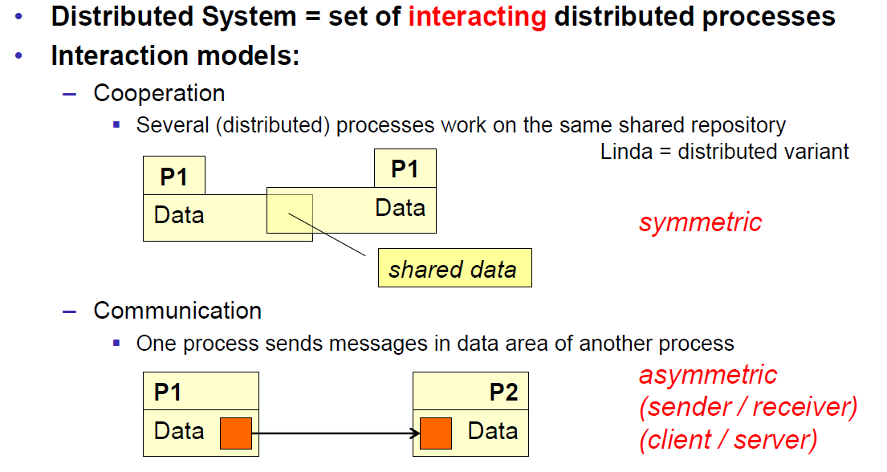

### Client/Server Model

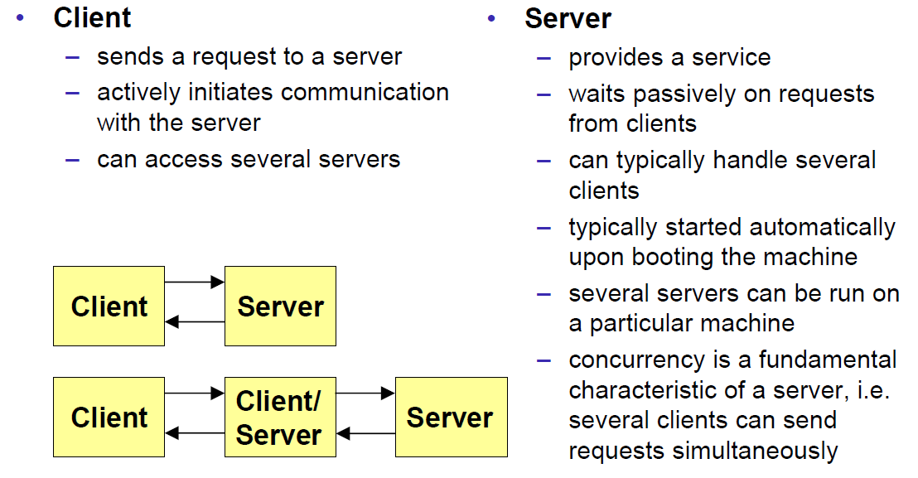

### Communication Models

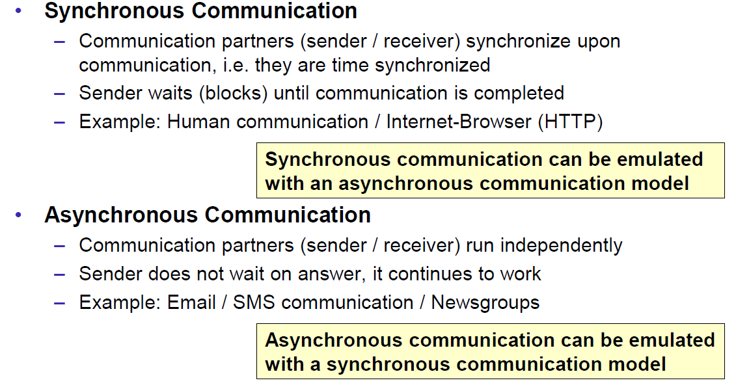

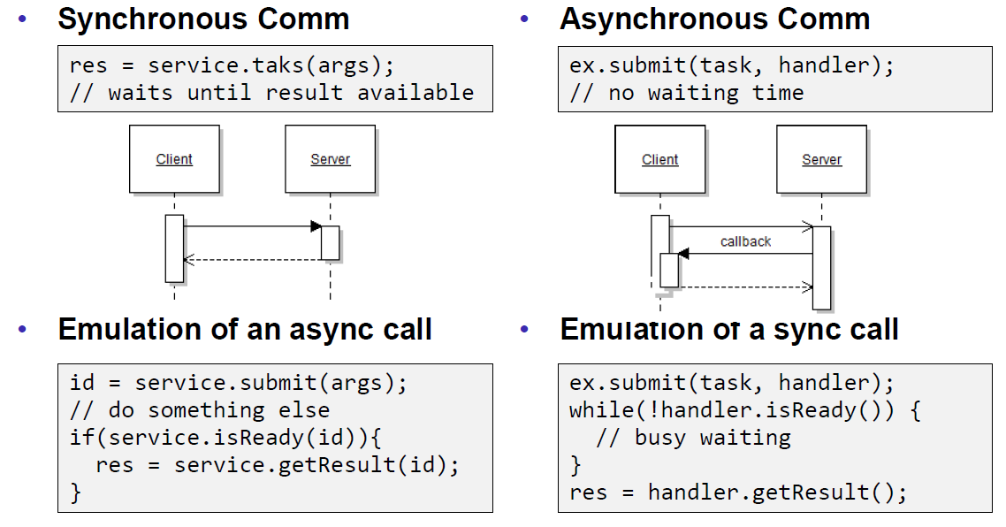

### Communication Styles

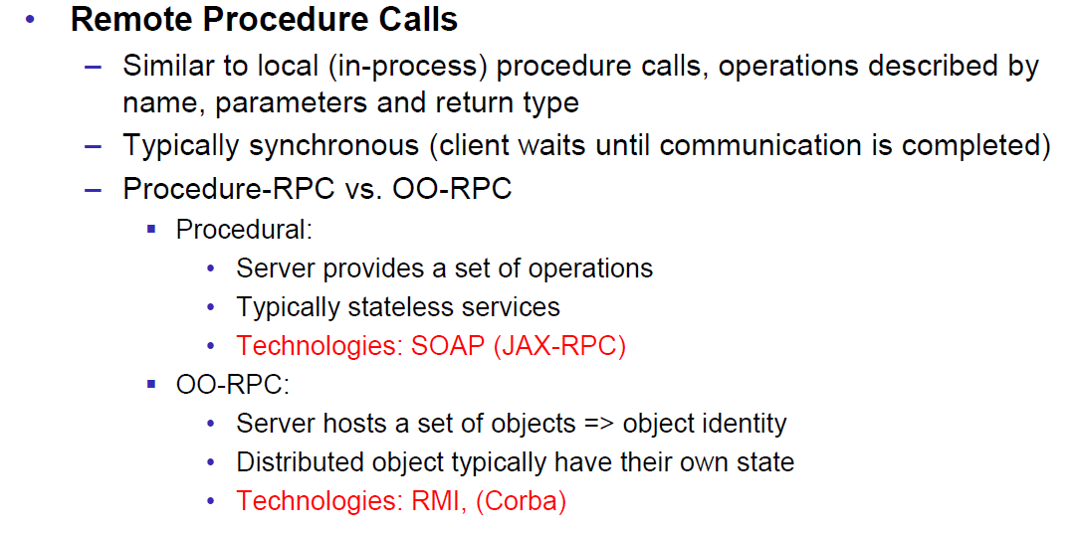

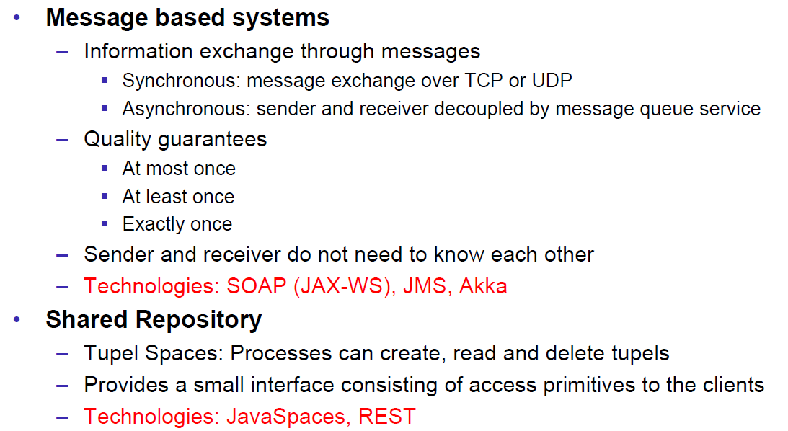

## Challenges of Distributed Systems

### Heterogeneity

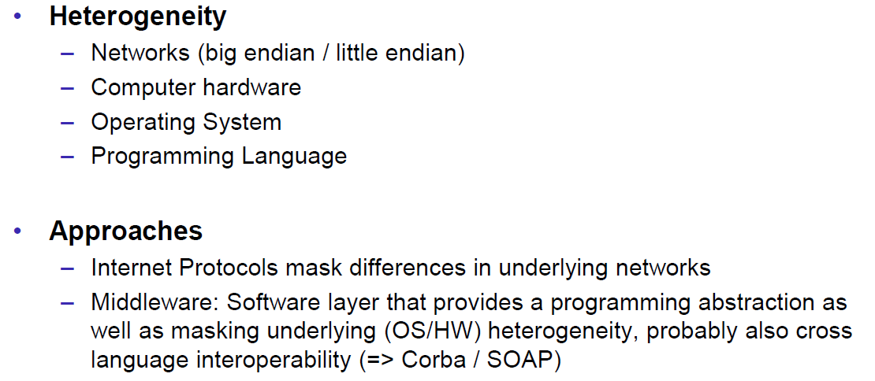

### Latency

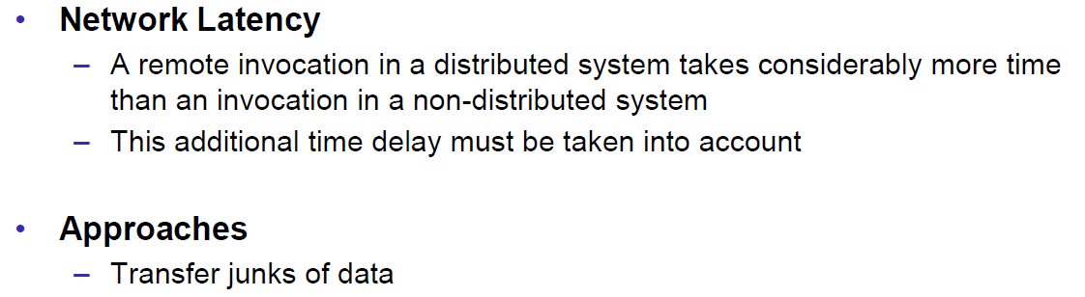

### Security

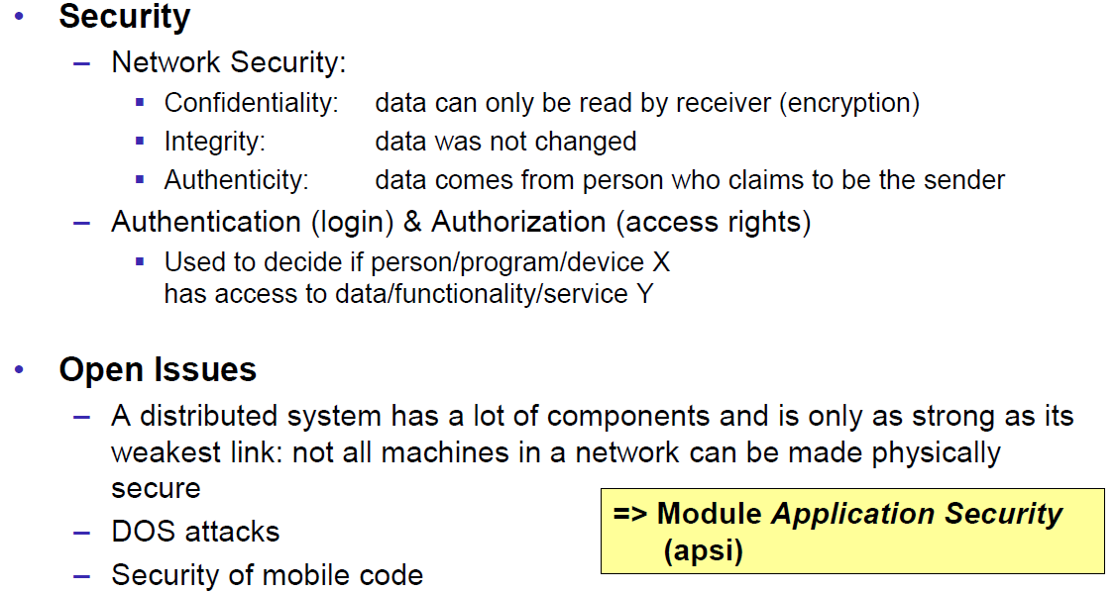

### Scalability

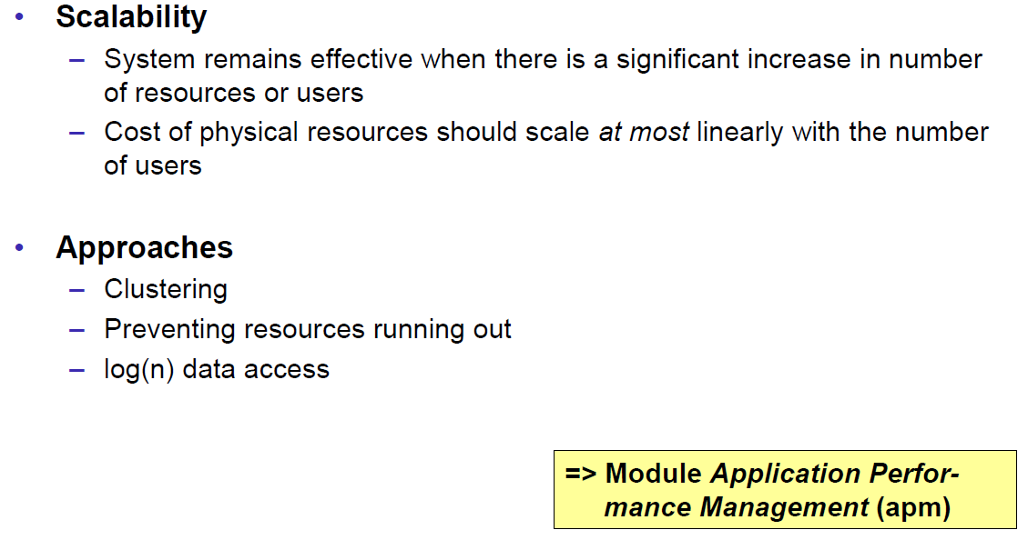

### Failures

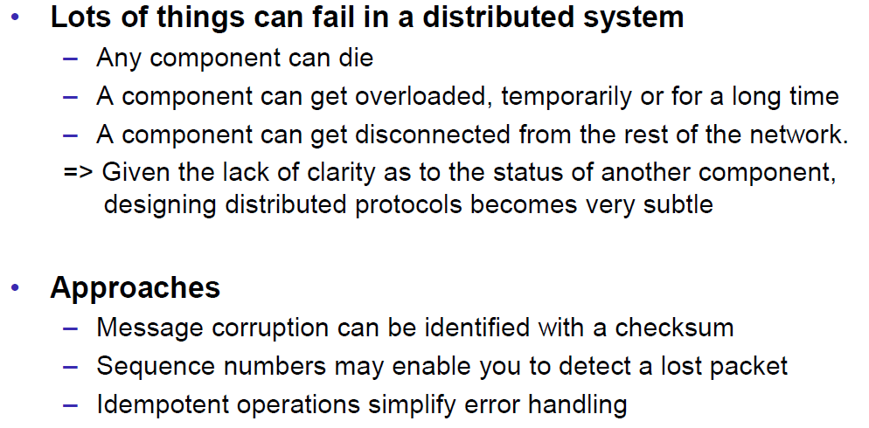

### Concurrency

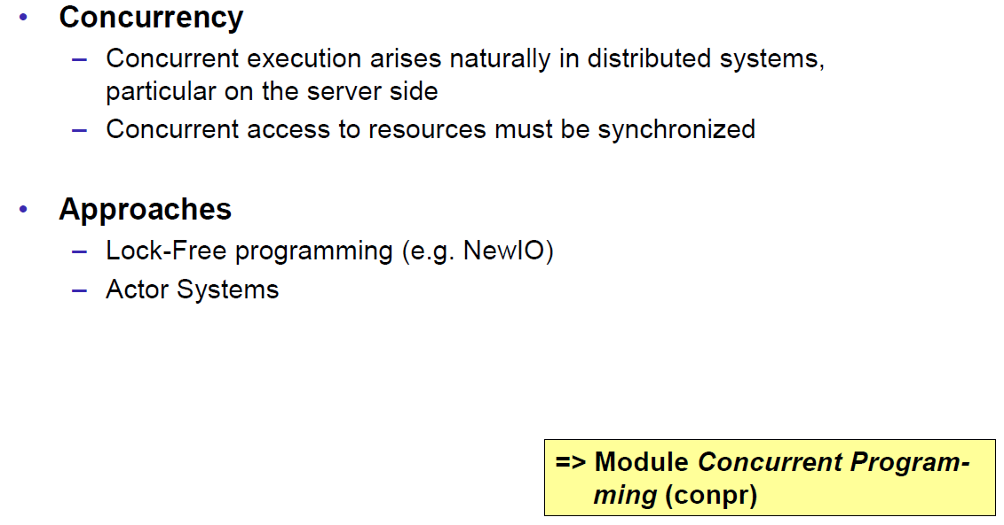

### Consistency

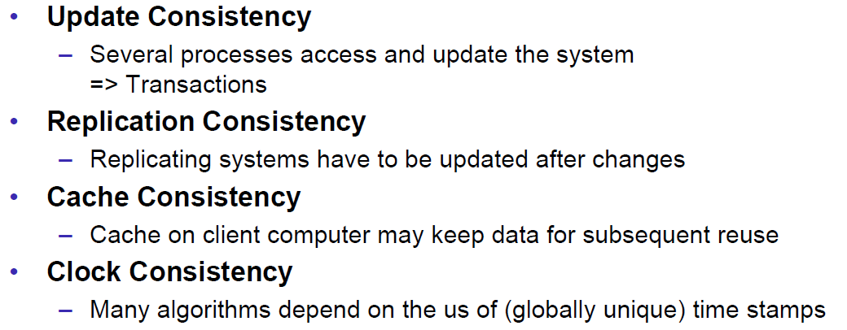

## Networking

### Protocol & Network Levels

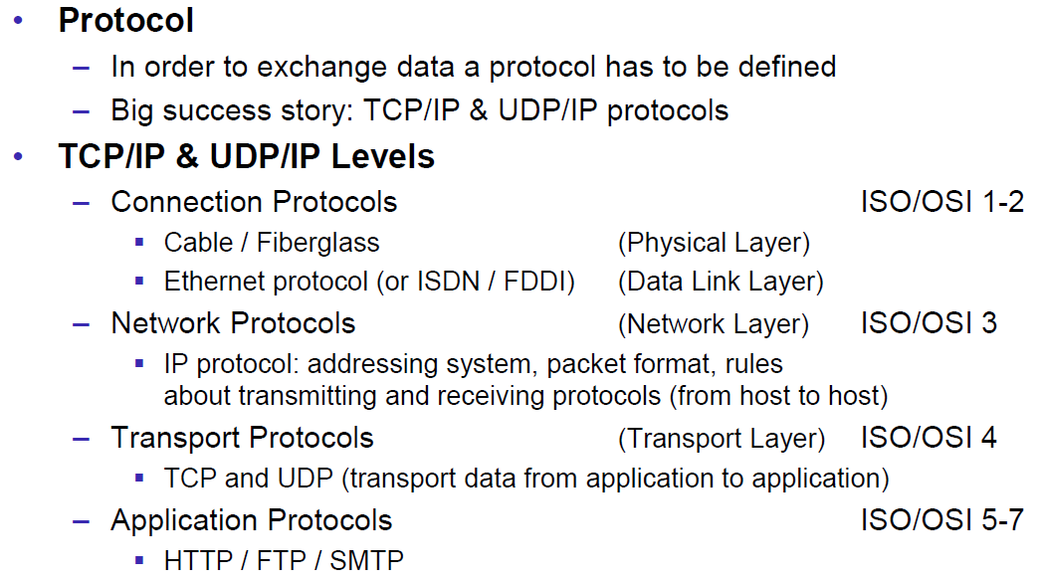

### IP Socket Connections

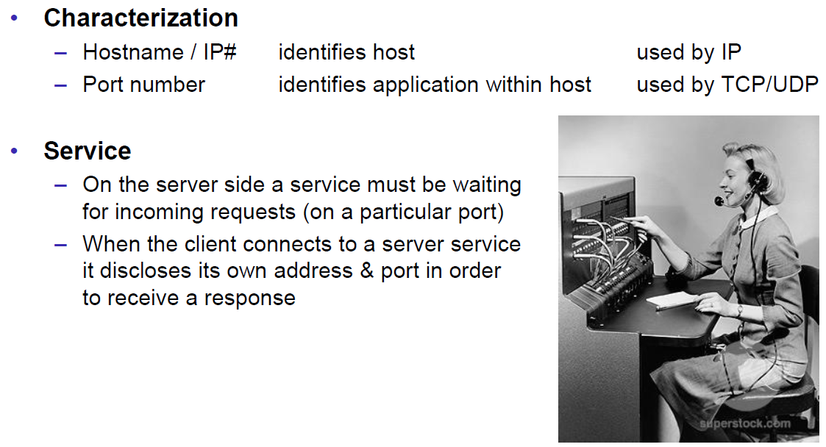

### IP Addressing

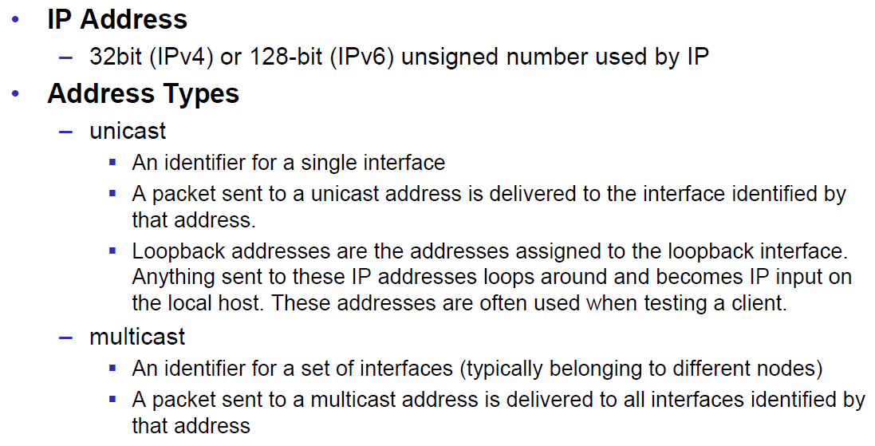

### TCP/UDP Common Port Numbers

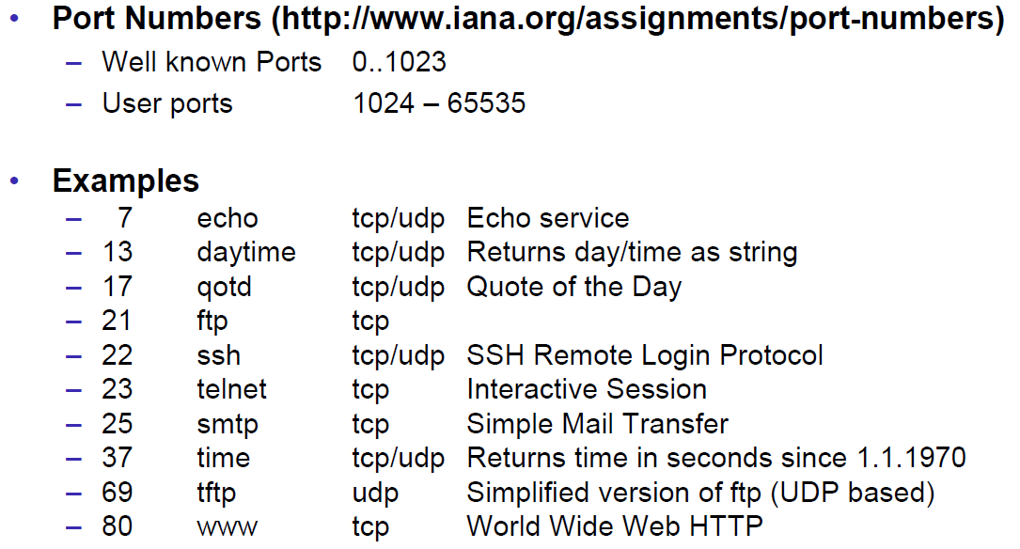

### InetAddress

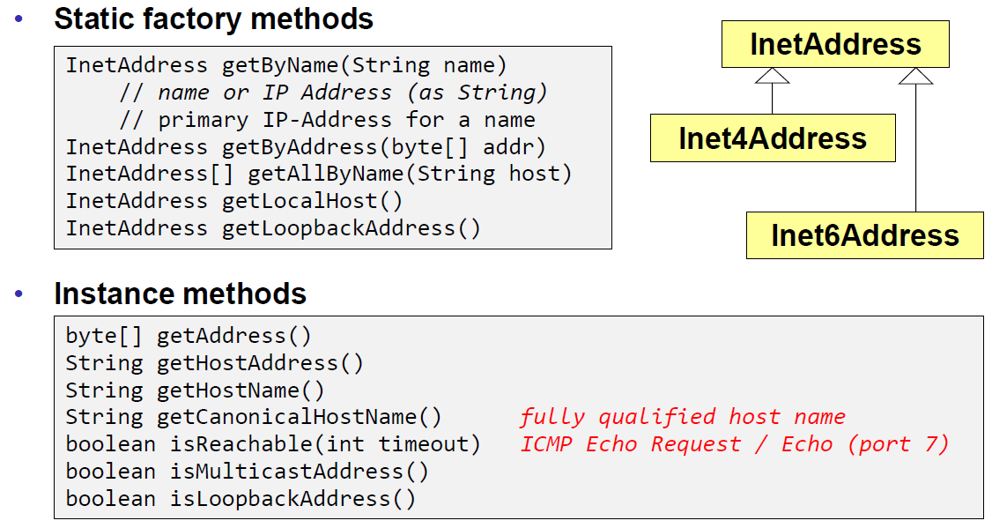

### Network Interfaces

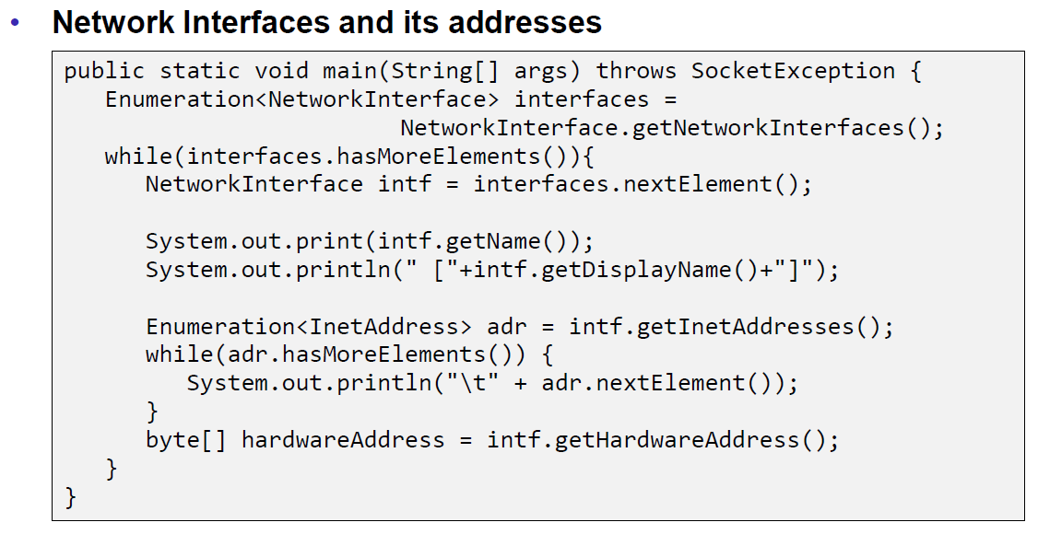

## Sockets

### Sockets

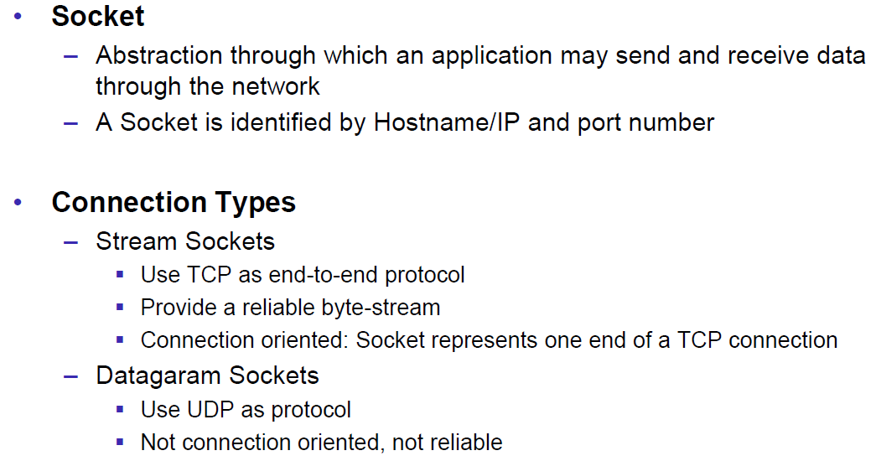

### TCP Sockets

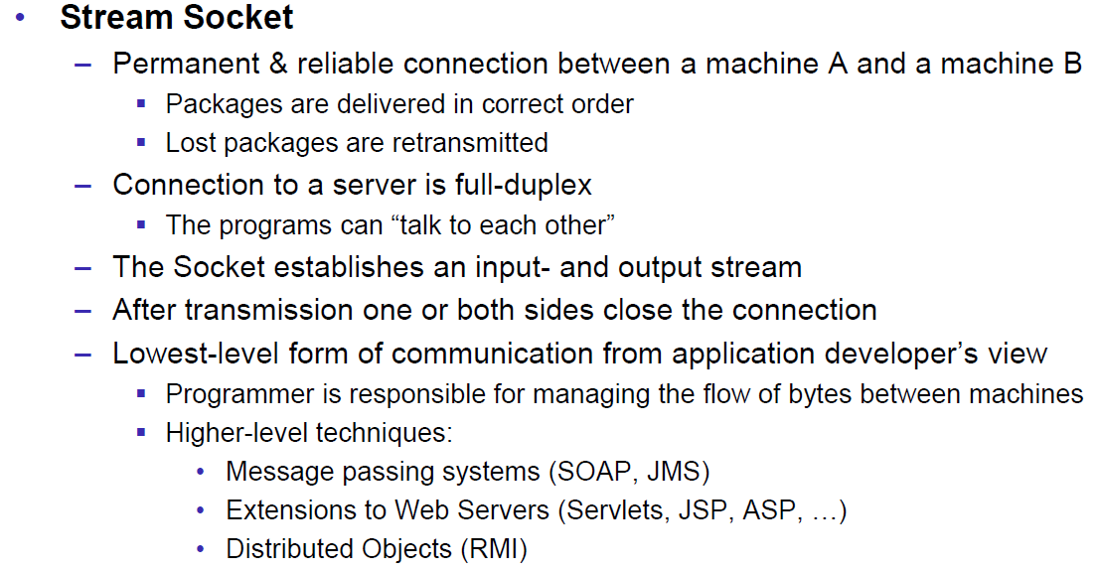

### Java Socket

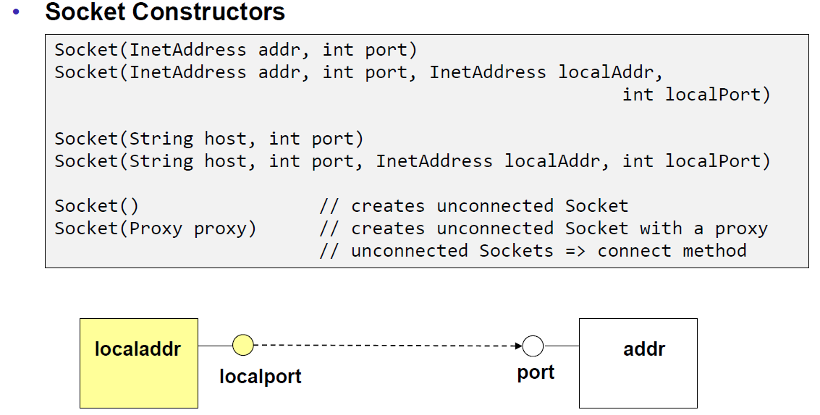

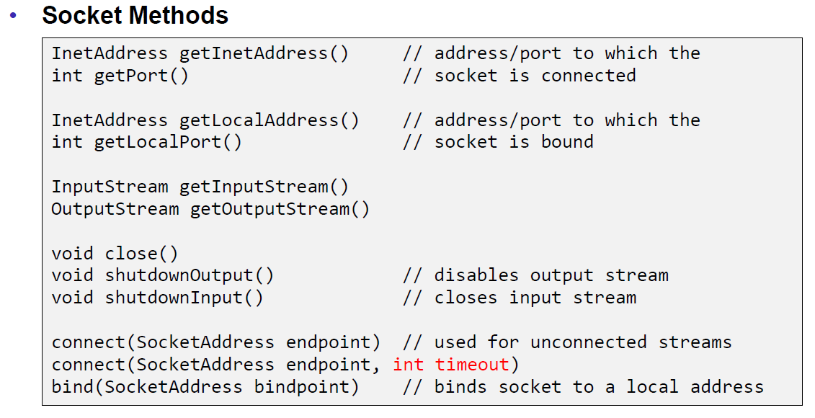

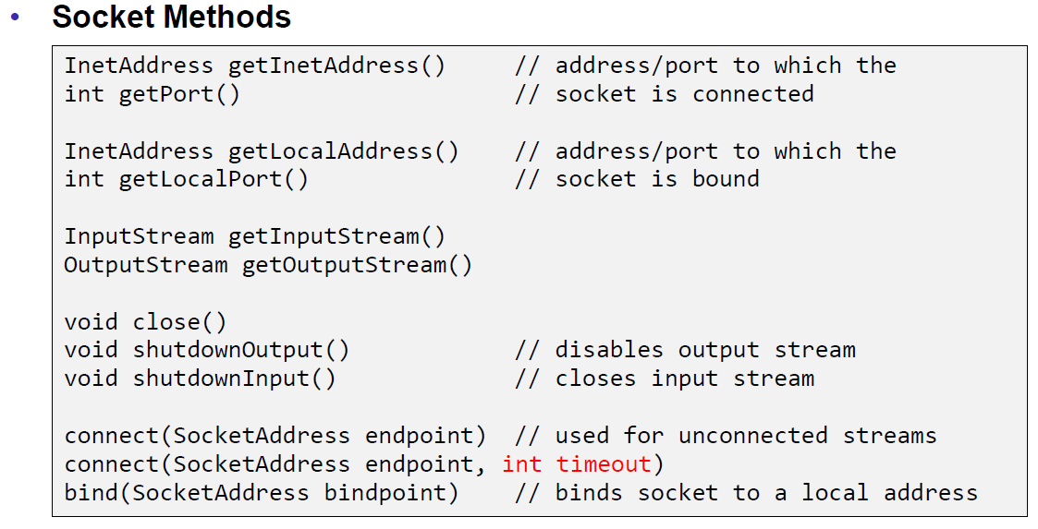

### Sample Client (Echo)

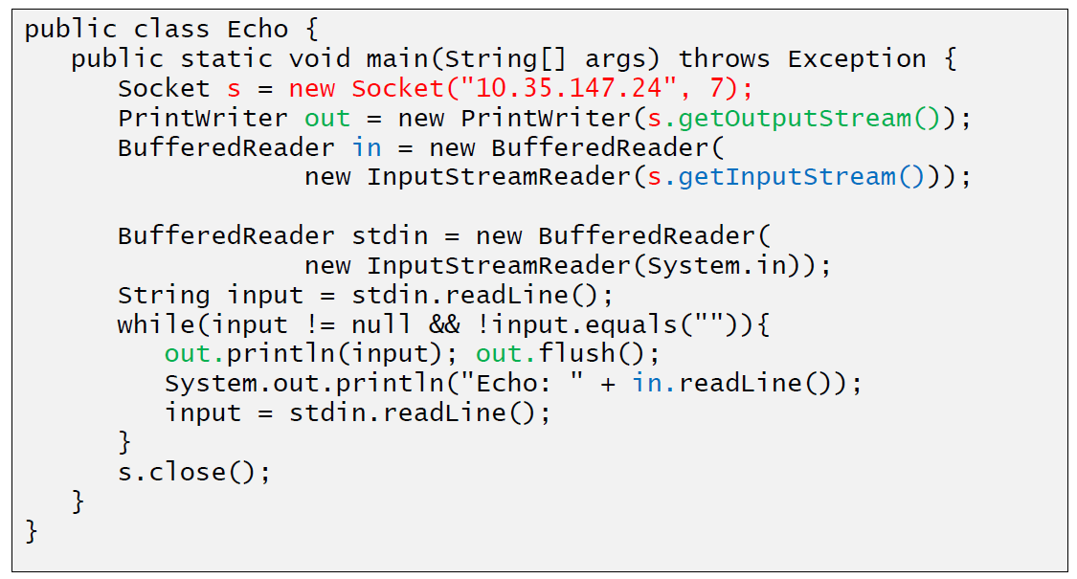

### Sample Client (Mailer)

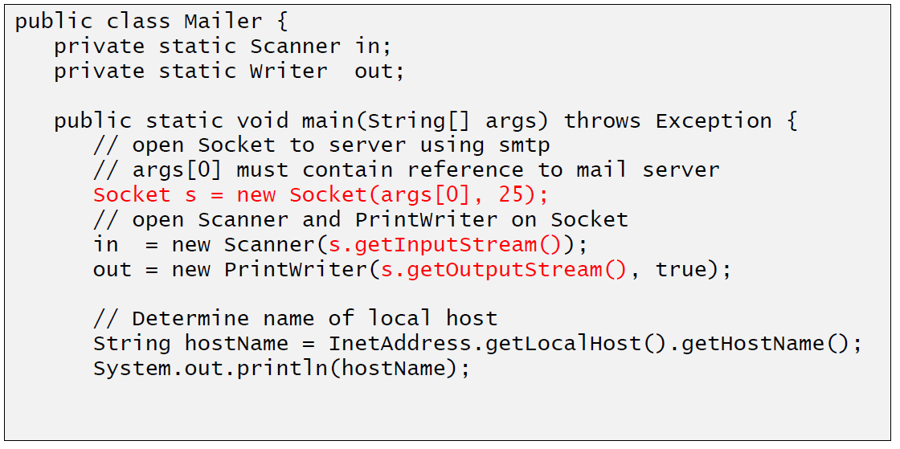

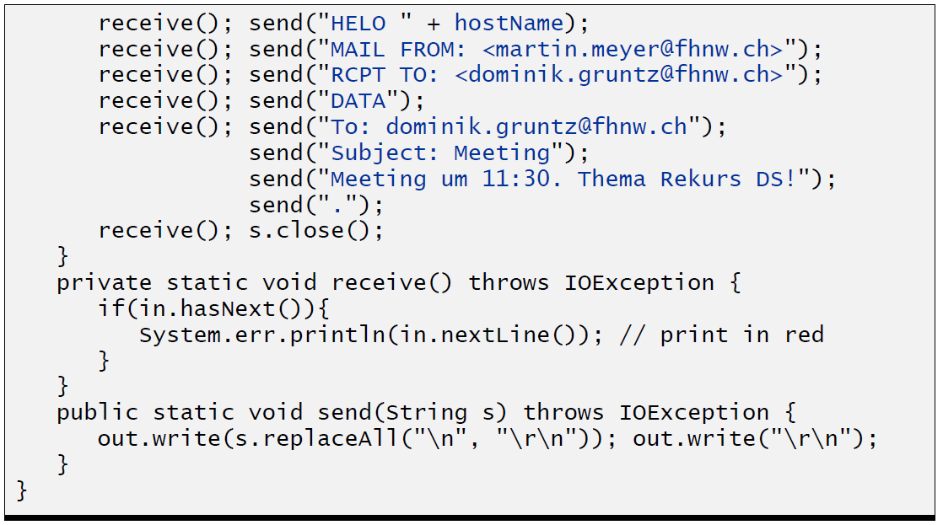

### ServerSocket

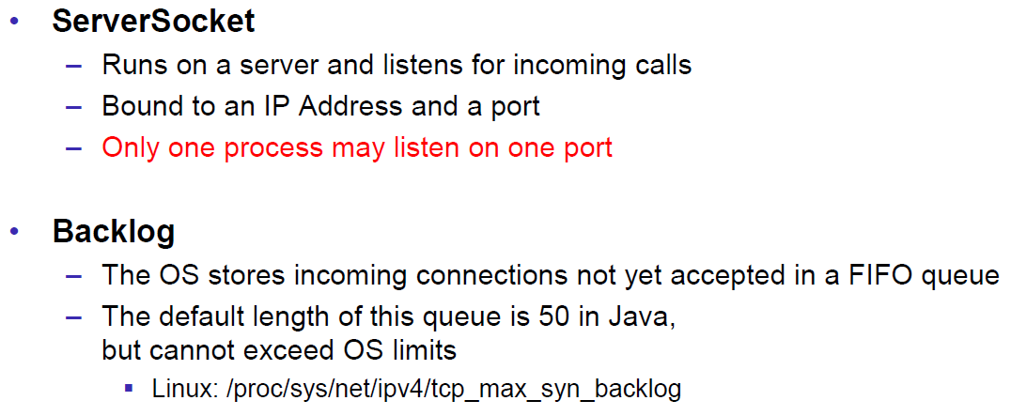

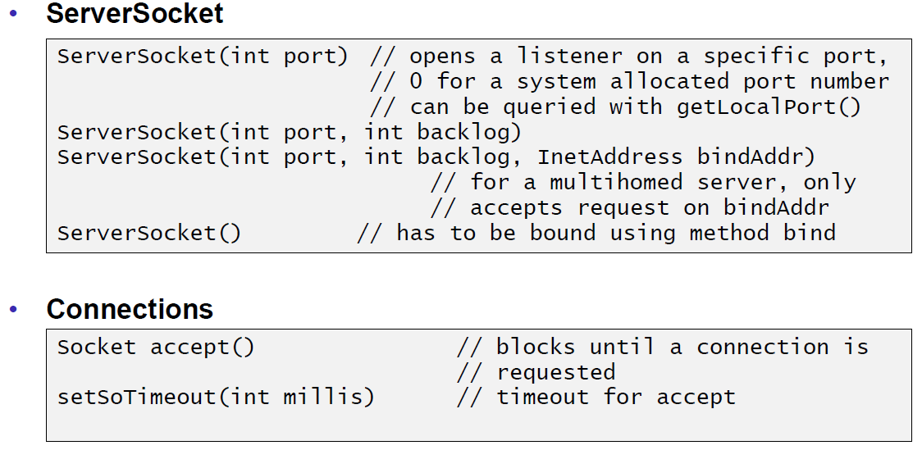

### Echo Server

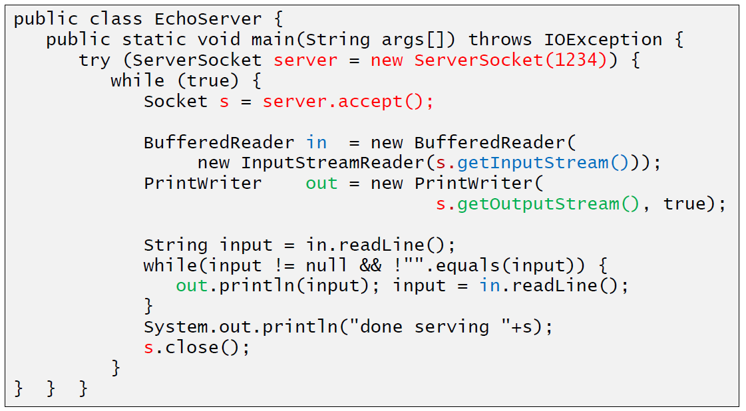

### Concurrent Echo Server

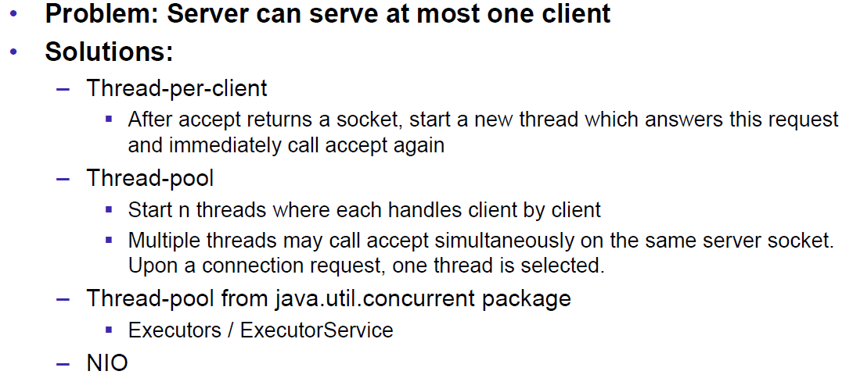

### Concurrent Echo Server (Threaded)

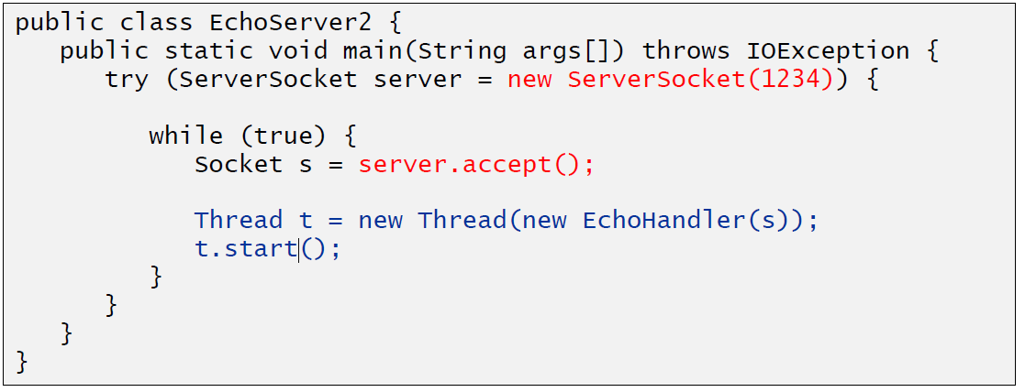

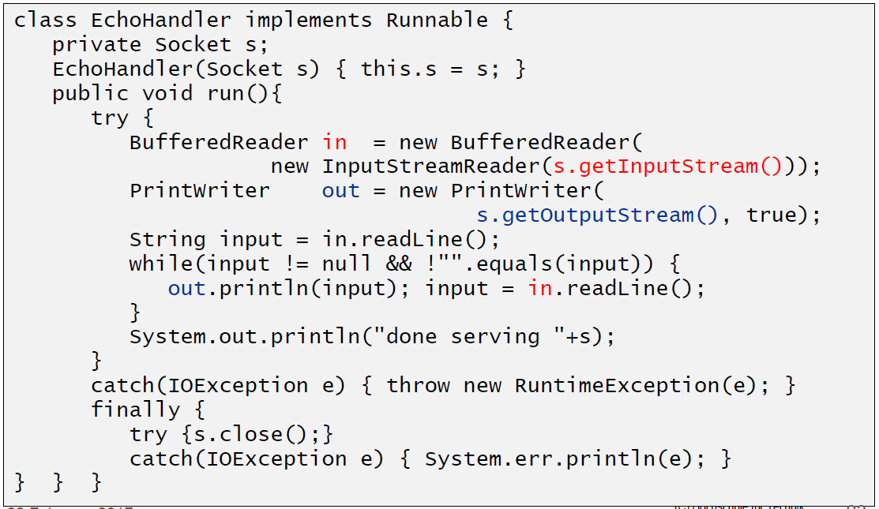

### Concurrent Echo Server (Limitierter Threadpool)

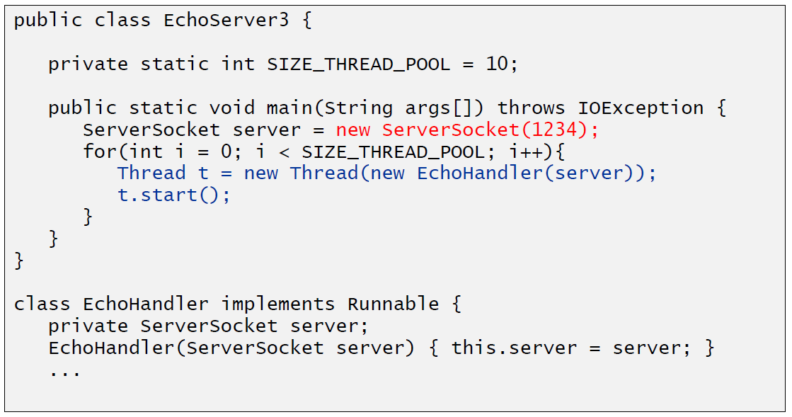

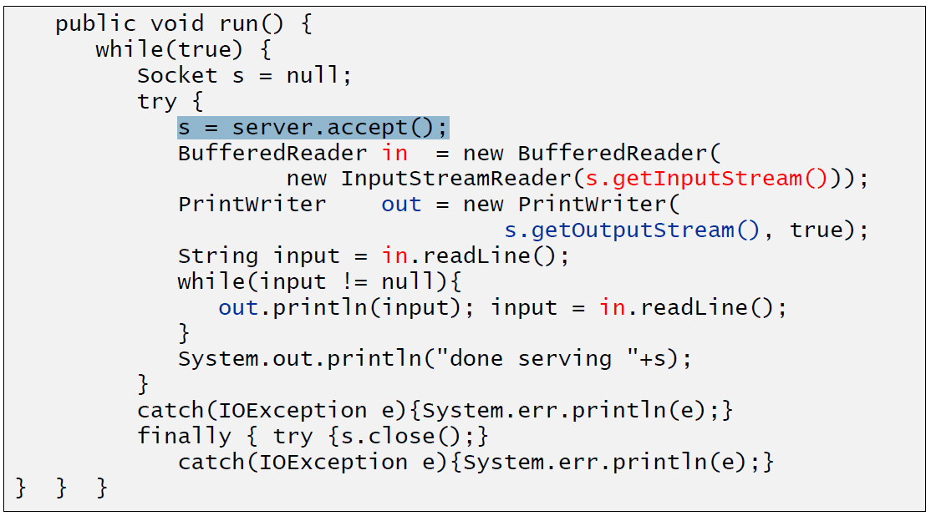

### Concurrent Echo Server (Dynamischer Threadpool)

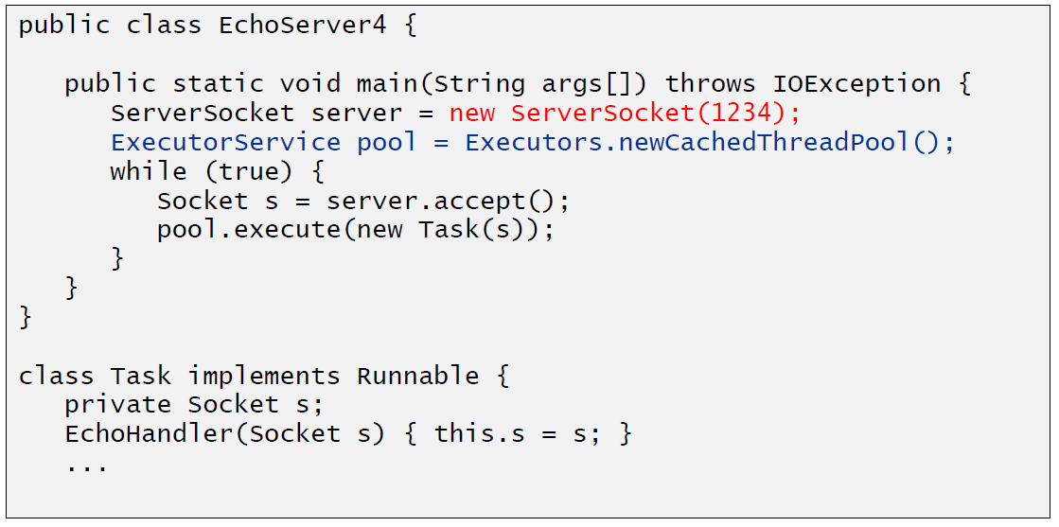

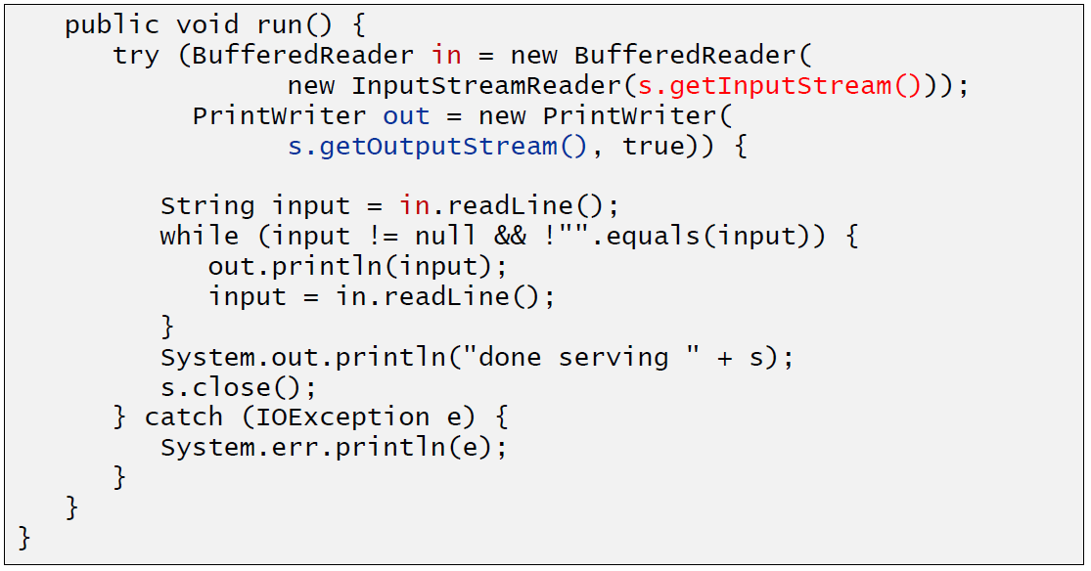

# Woche 2

## Input and Output Streams

### OutputStream

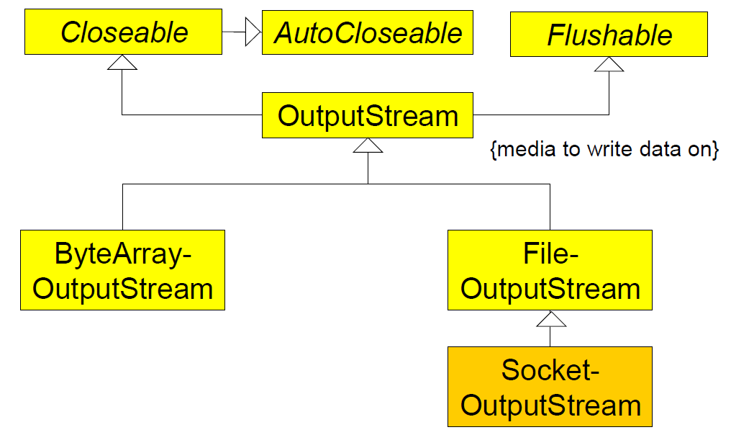

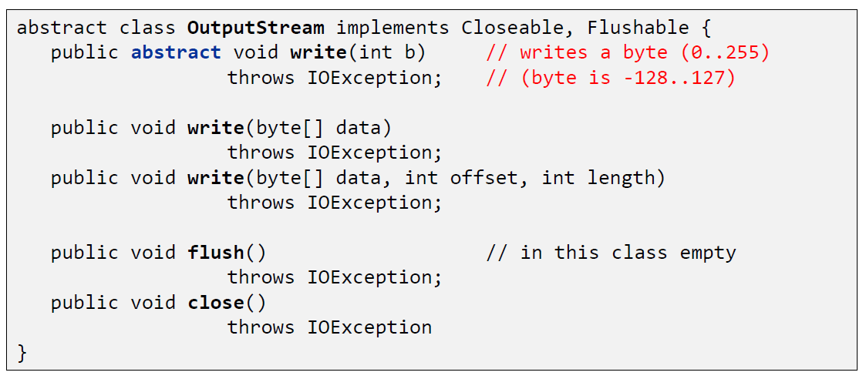

### InputStream

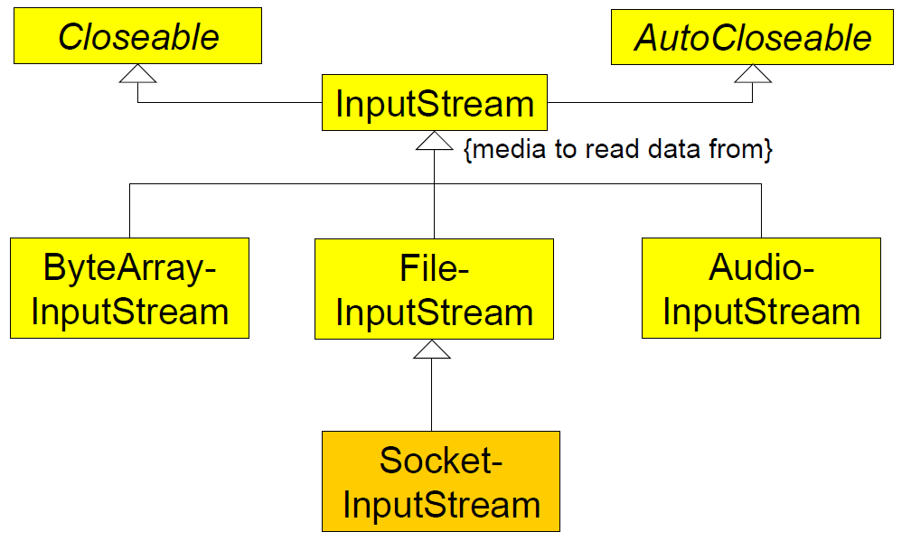

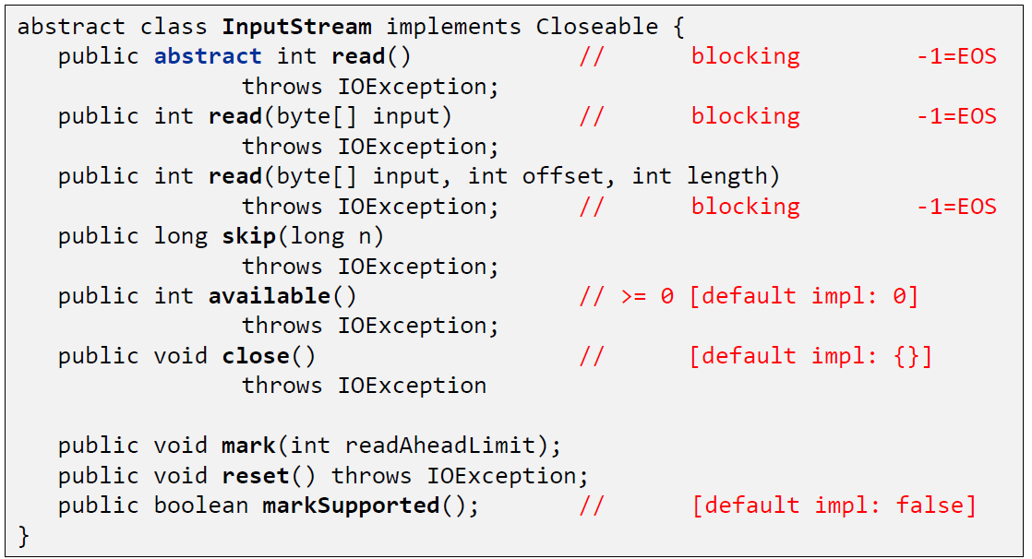

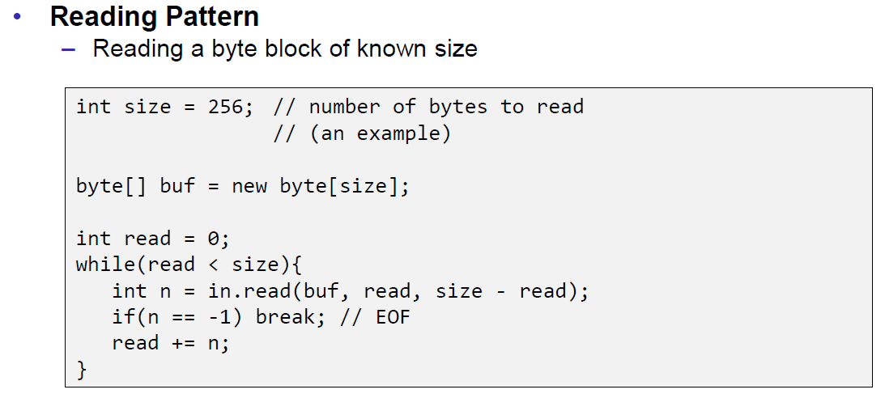

## Filter Streams

### FilterOutputStream

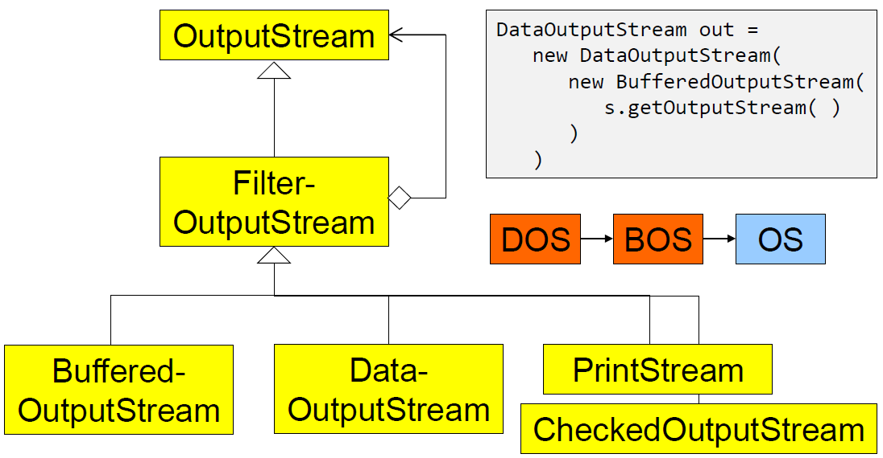

### DataOutputStream

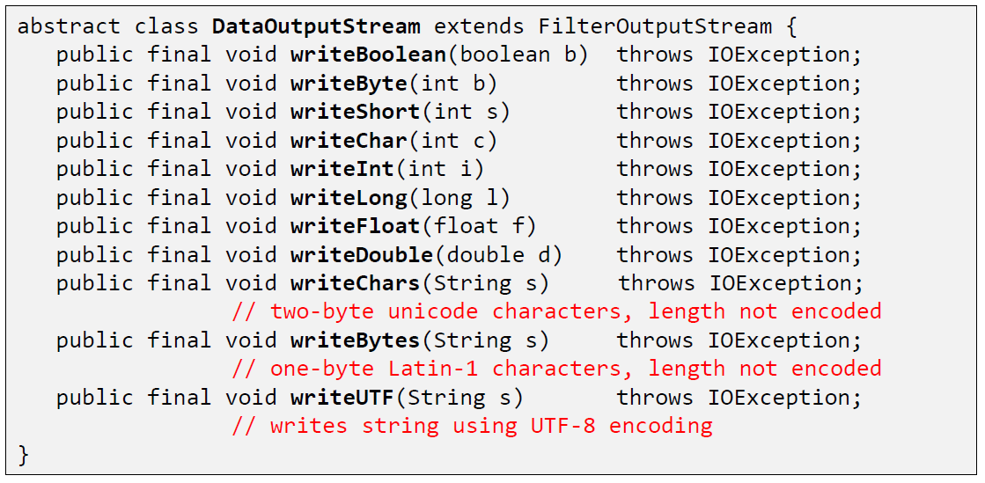

### DataOutputStream with writeInt

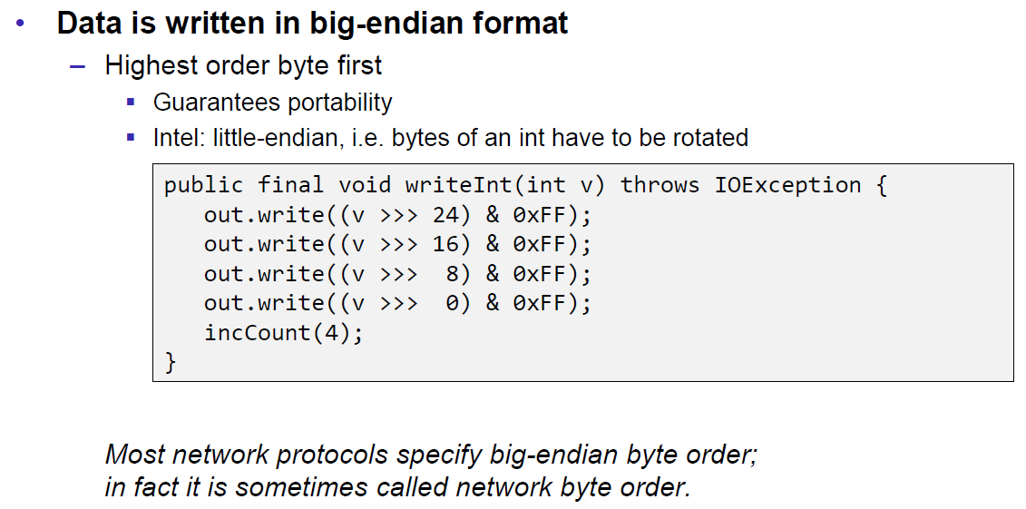

### DataOutputStream with writeUTF

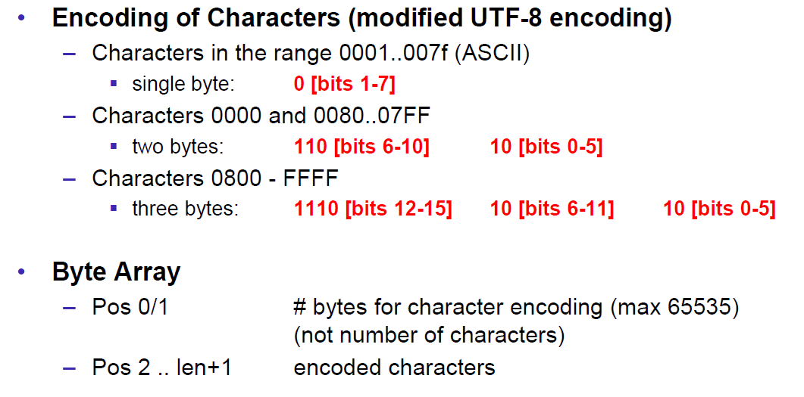

### PrintStream

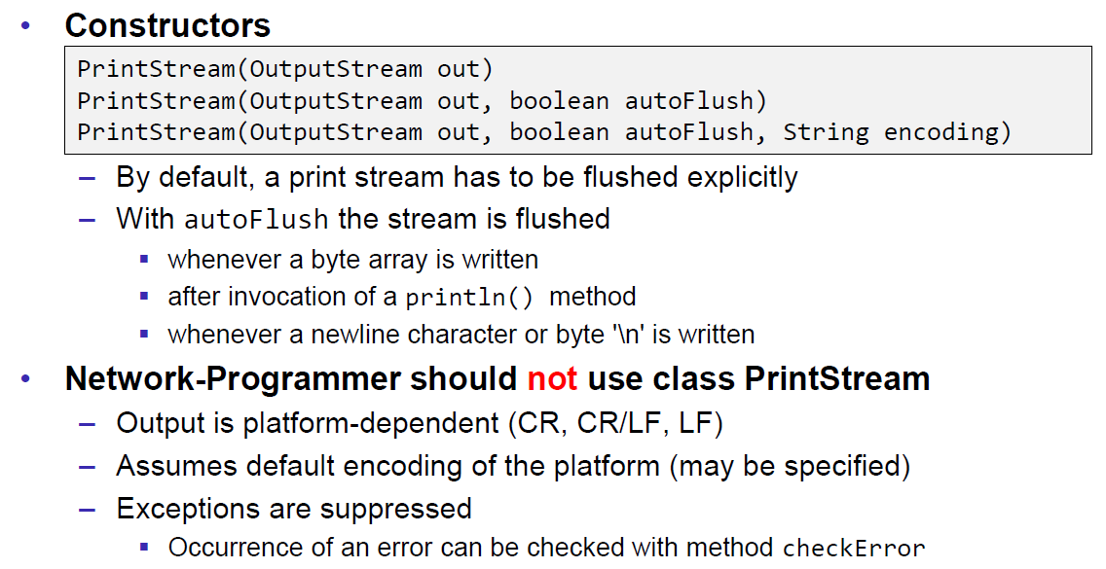

### FilterInputStream

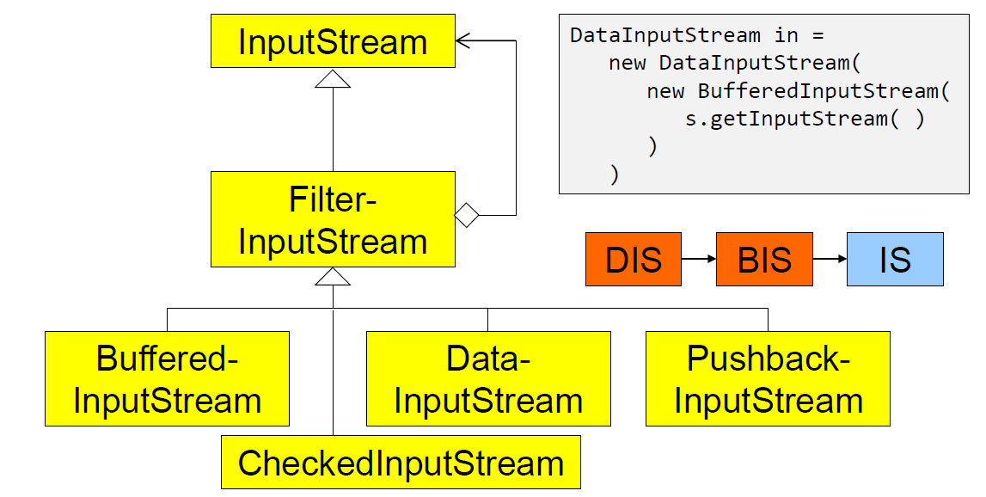

### DataInputStream

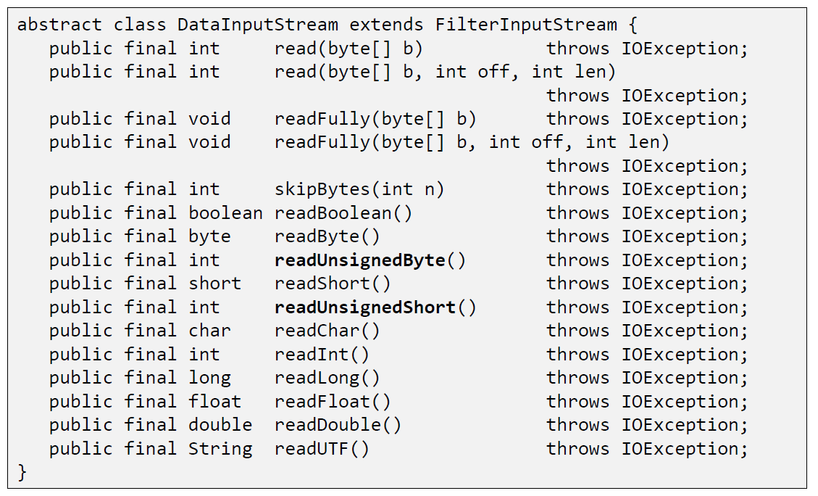

### DataInputStream with readFully

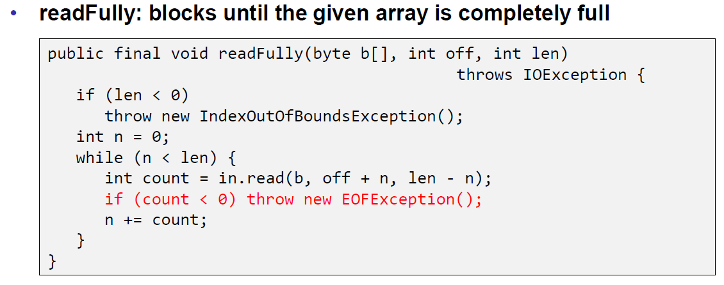

### Filter Streams

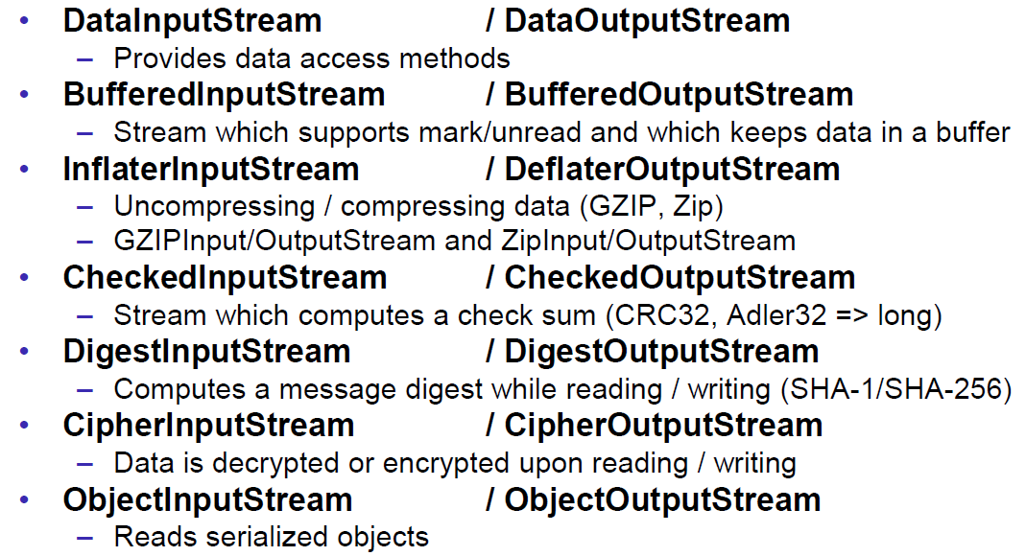

## Object Streams & Serialization

### ObjectStream

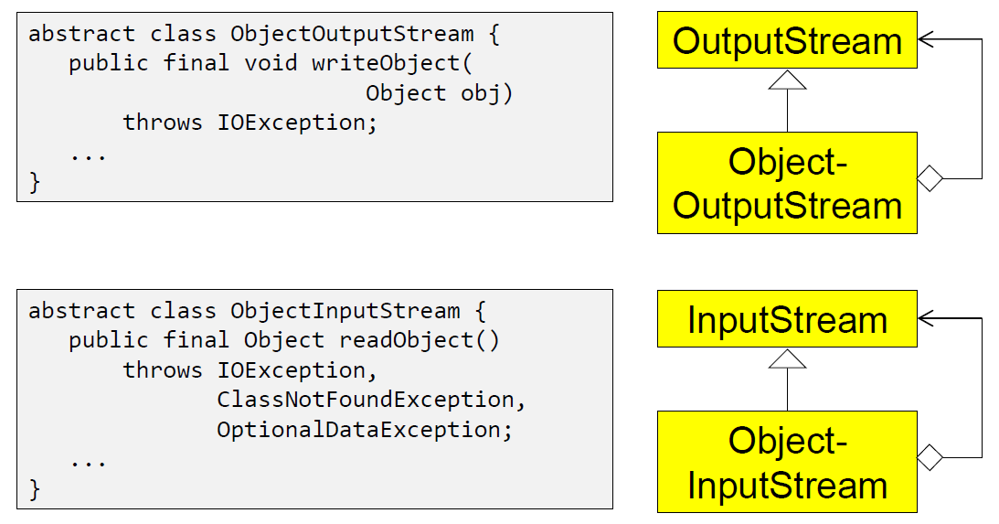

### Serialization with ObjectStream

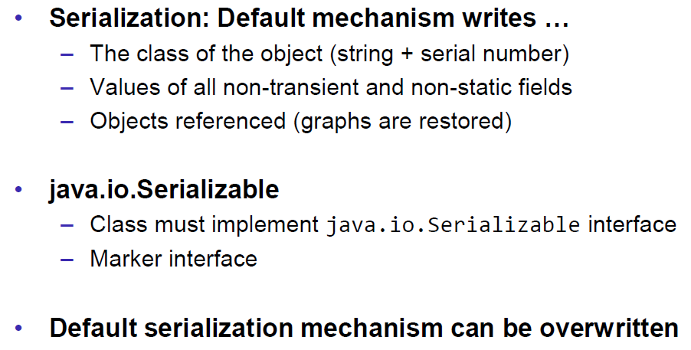

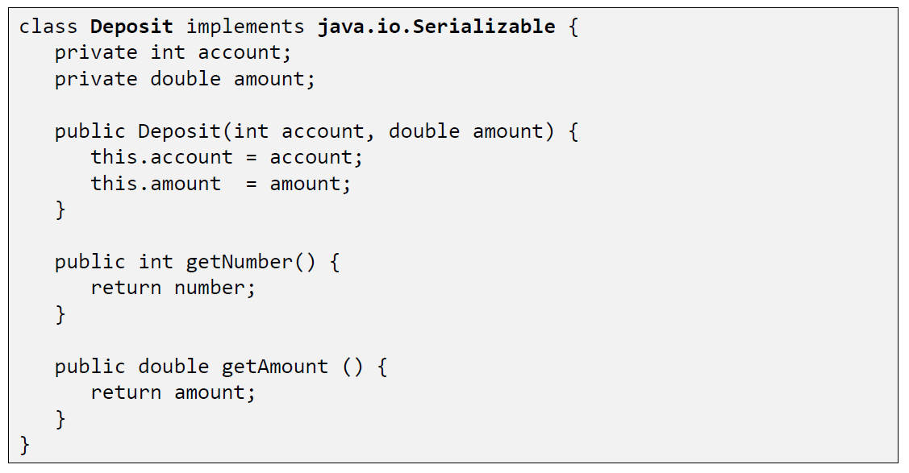

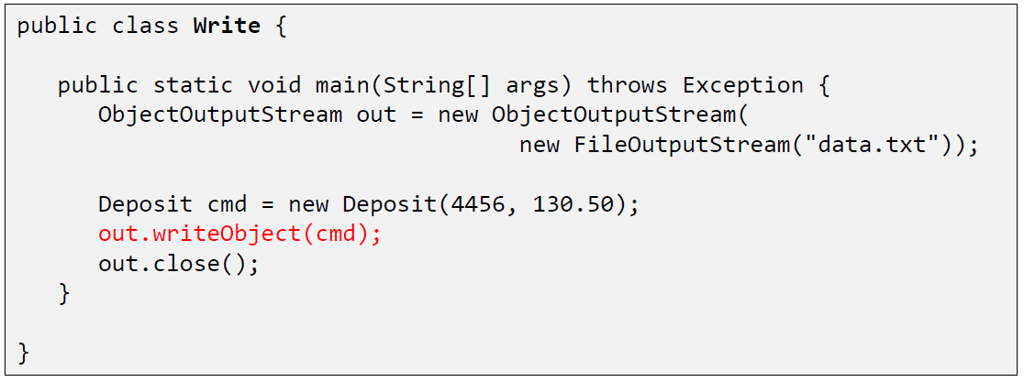

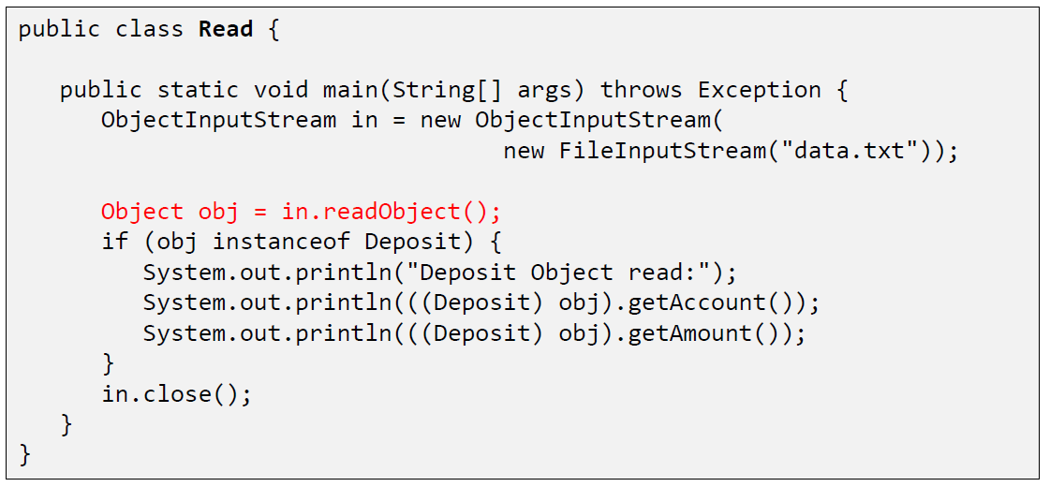

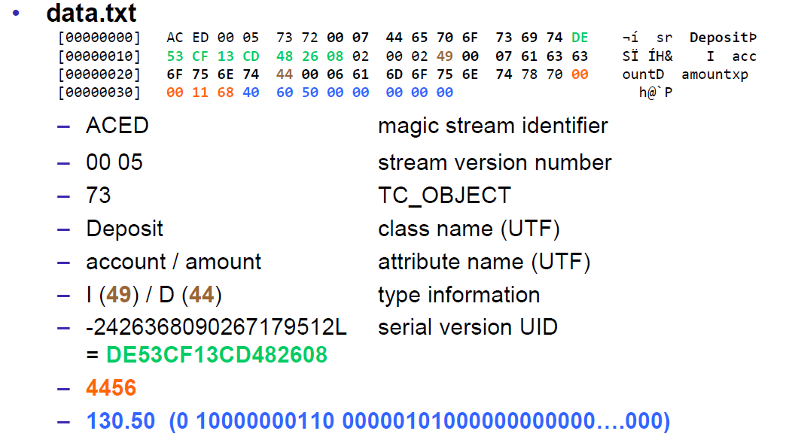

### Serial Version Number

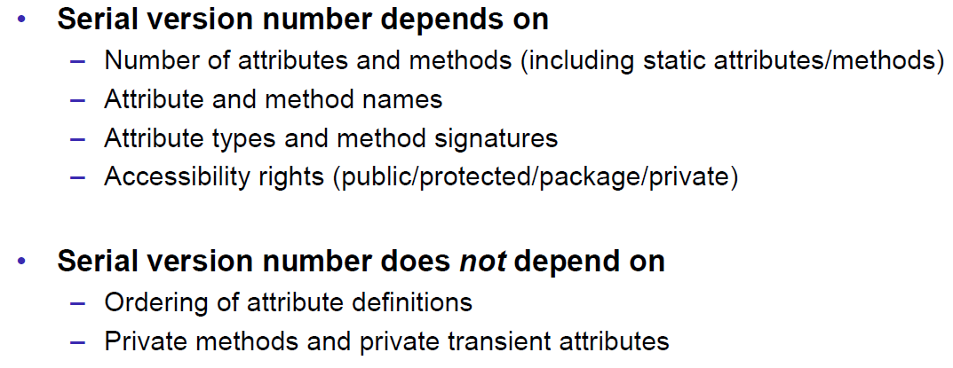

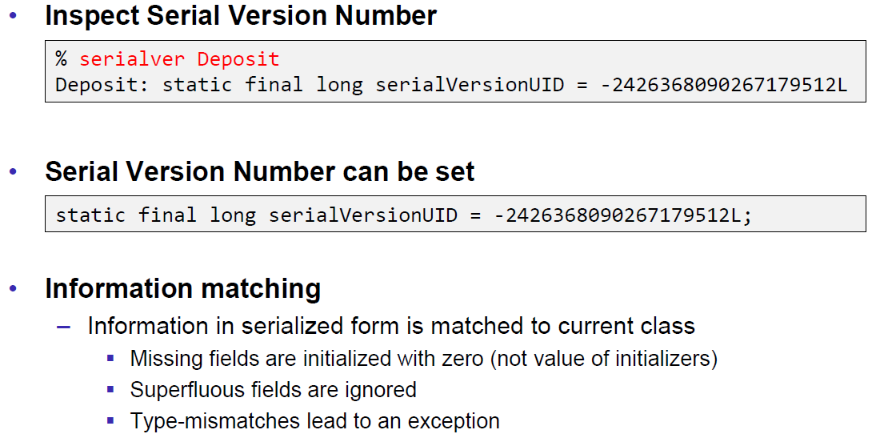

### Serialization Customization

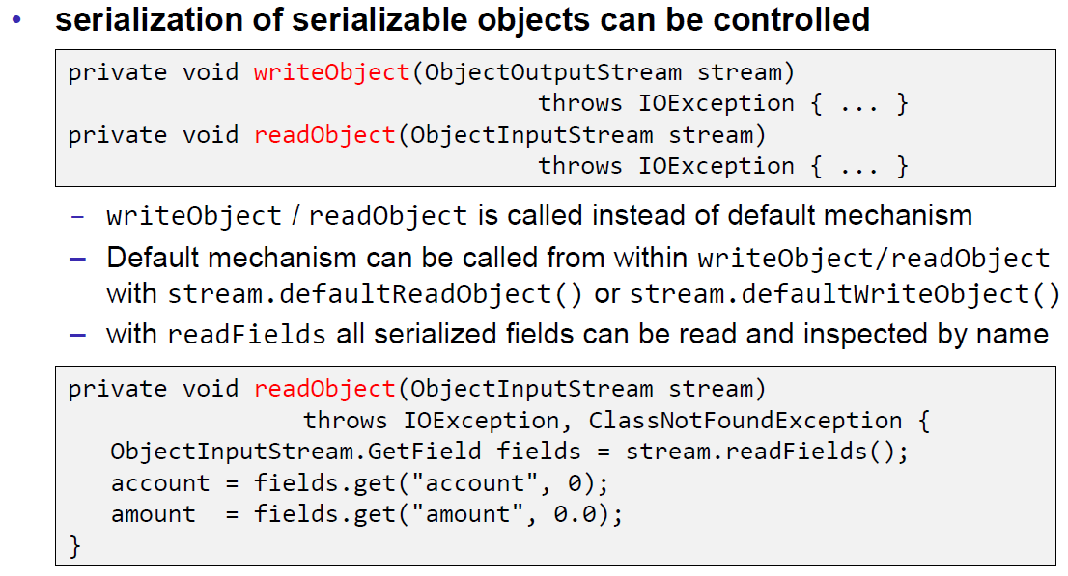

### Serialization Hints

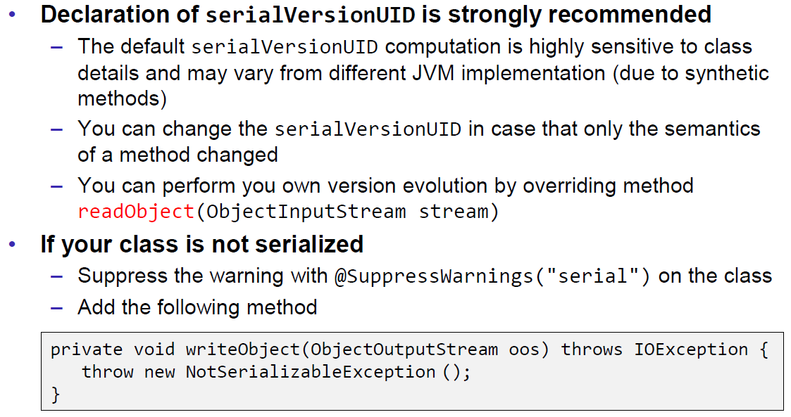

## Sending and Receiving Data

### Framing

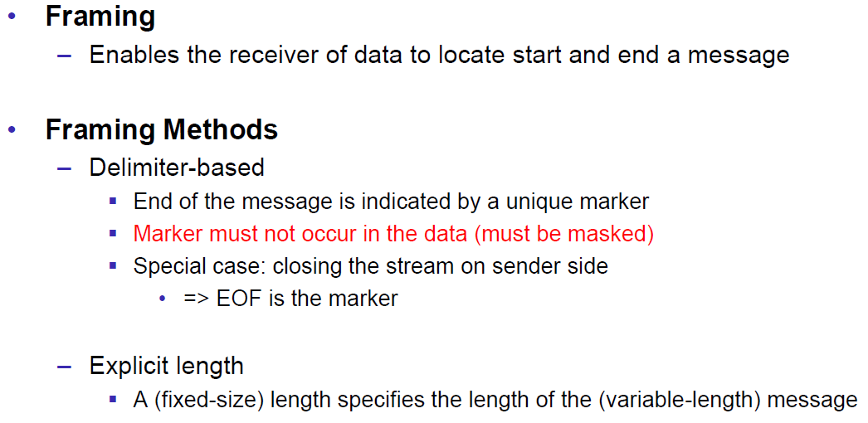

### Example of Framing

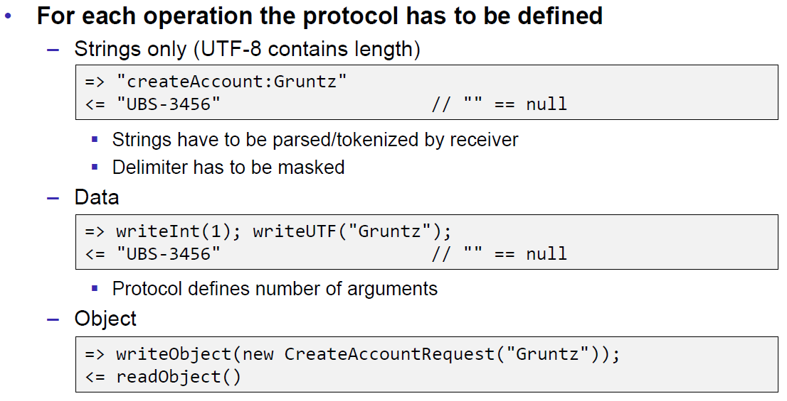

## Summary

### Whole Picture of Input Streams

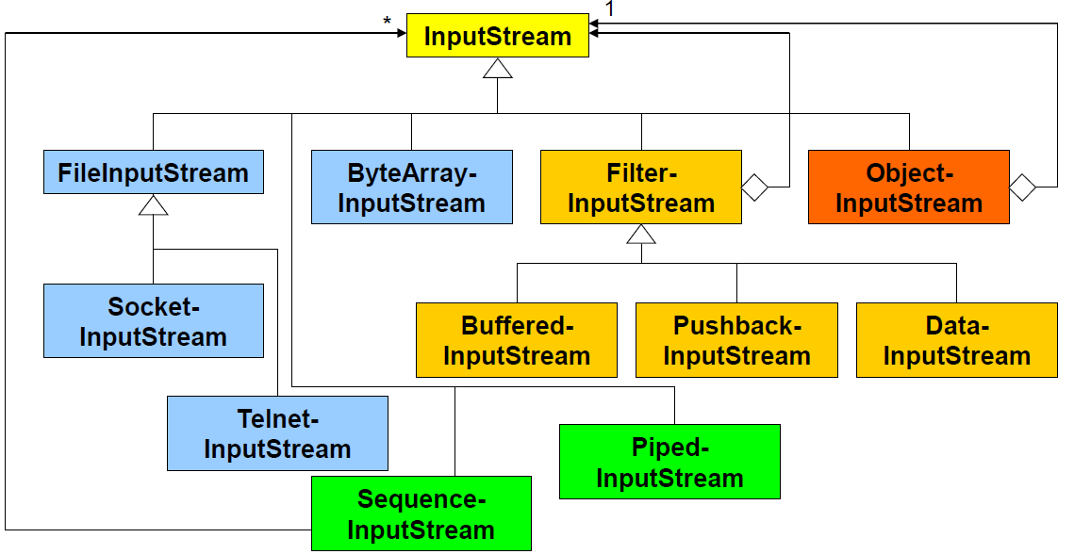

### Whole Picture of Output Streams

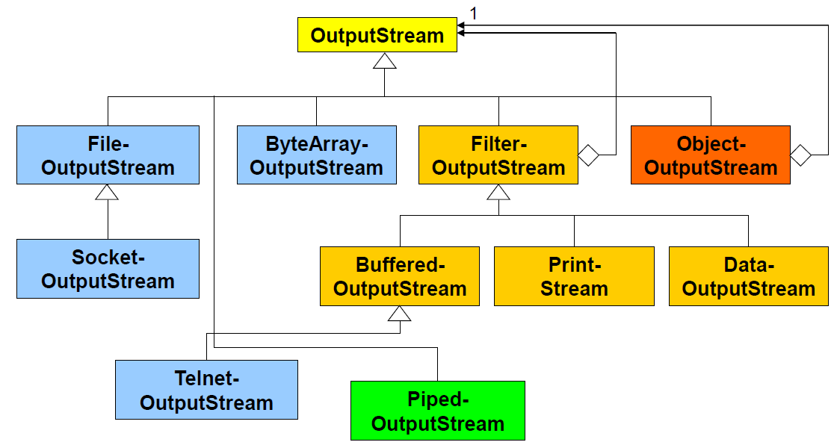

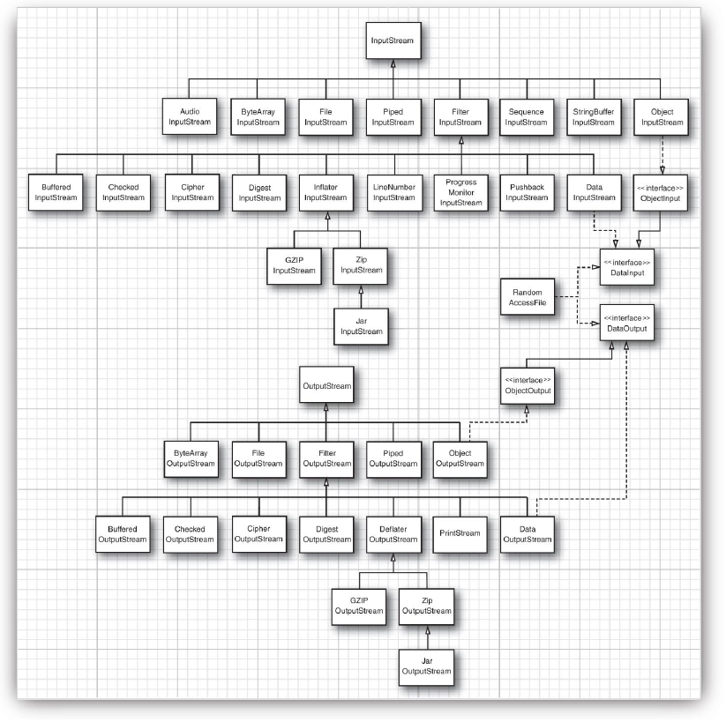

### Reading and Writing Text (Unicode Strings)

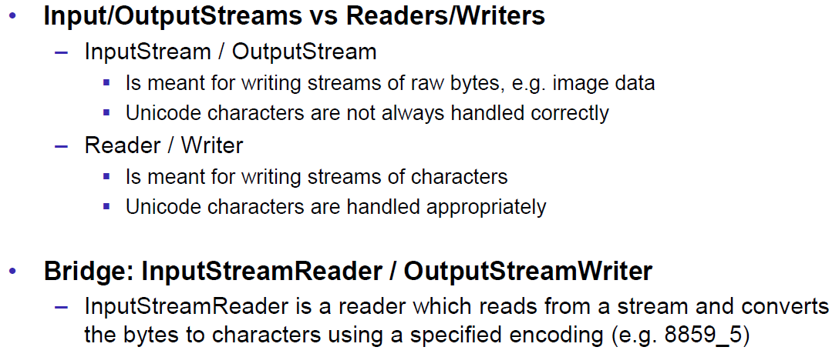

### Whole Picture of Reader

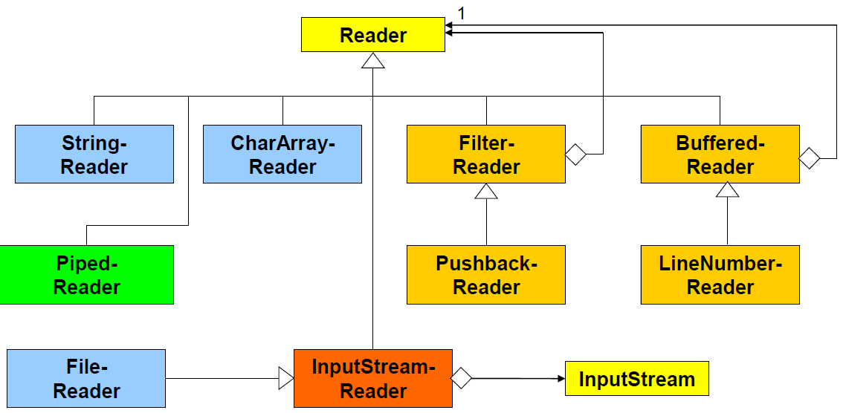

### Whole Picture of Writer

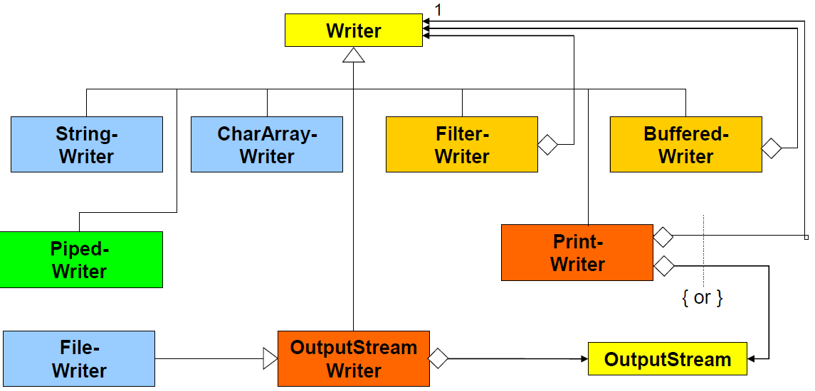

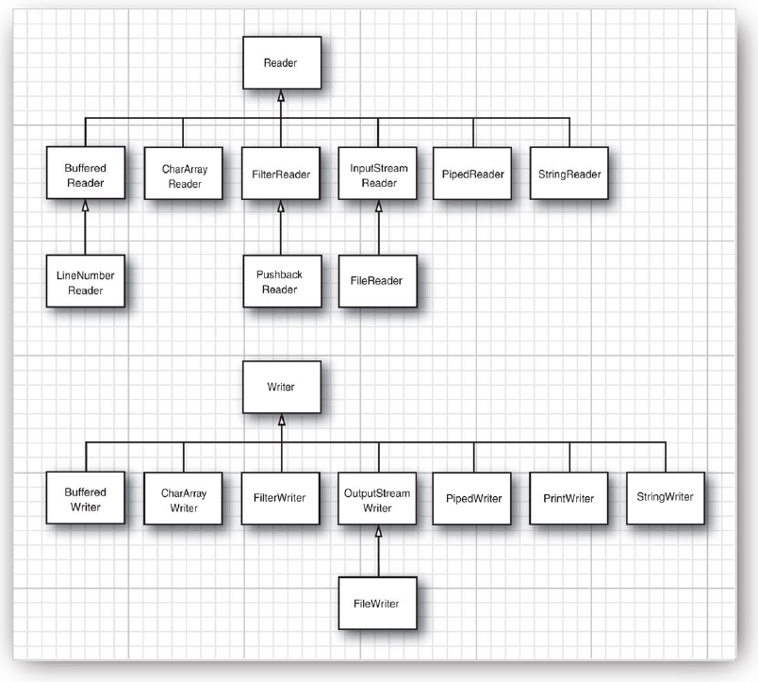

## Controlling Socket Behaviors

### Blocking and Timeouts

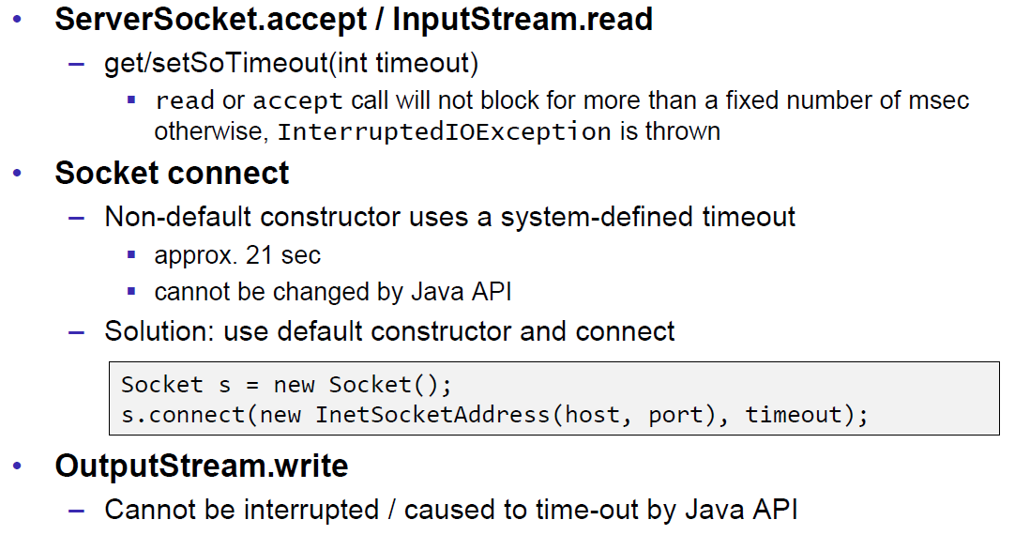

### Send and Receive Buffer Size

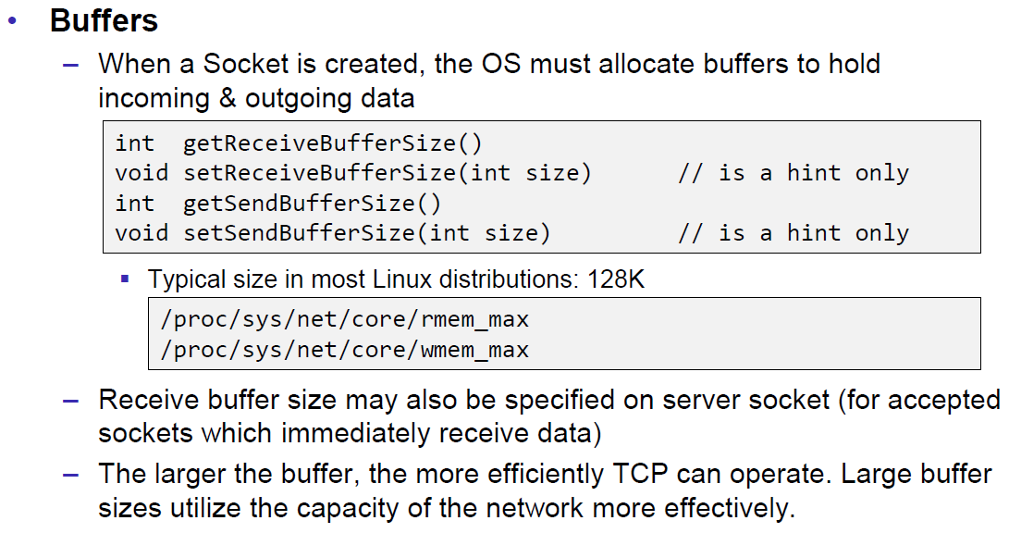

### Package Delay

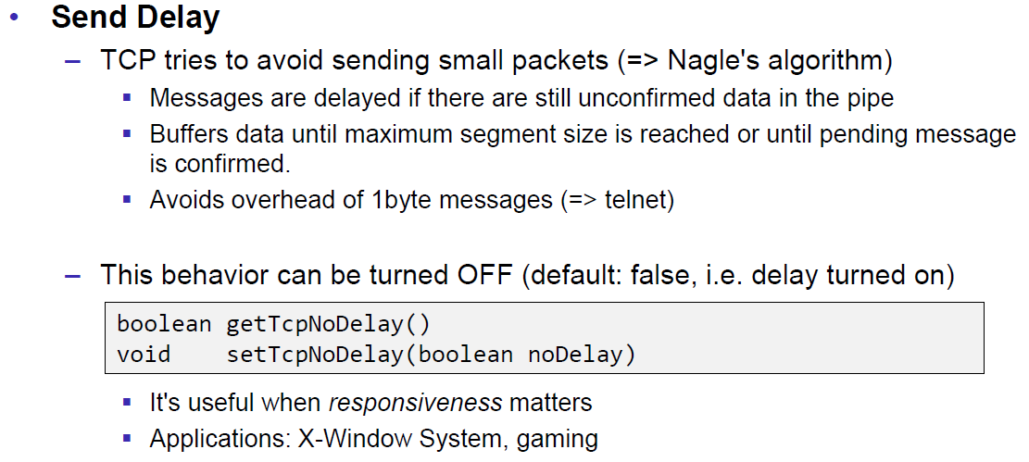

## Closing Connections

### Closing Connections

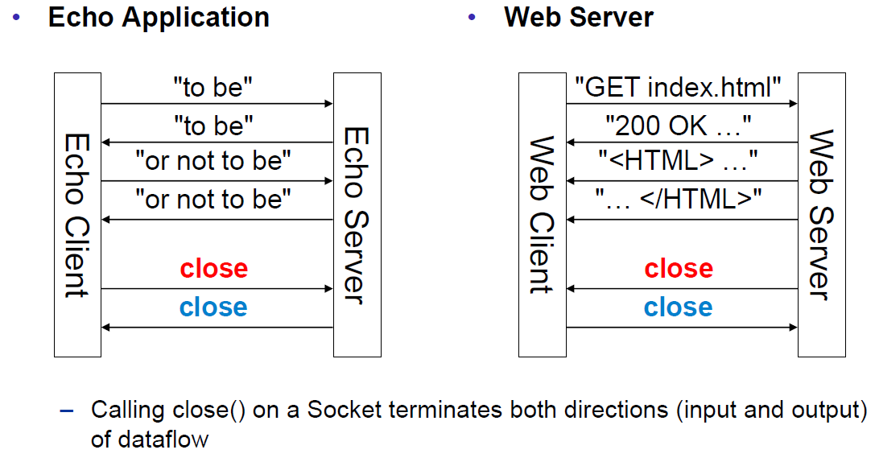

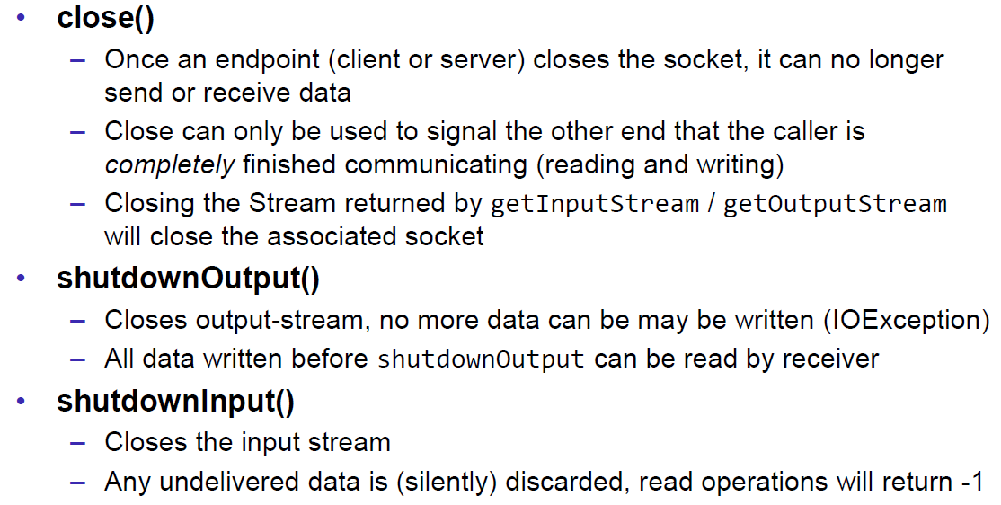

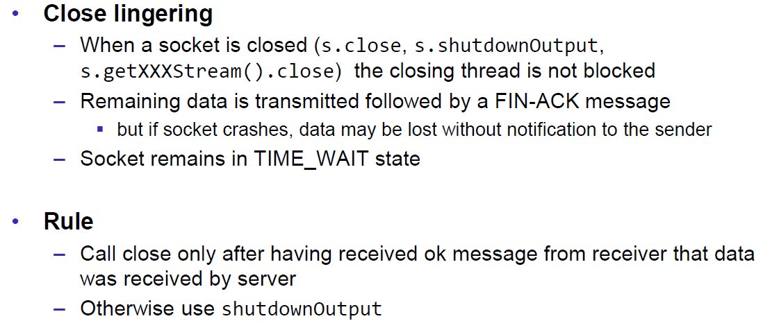

### Example of a Close Test

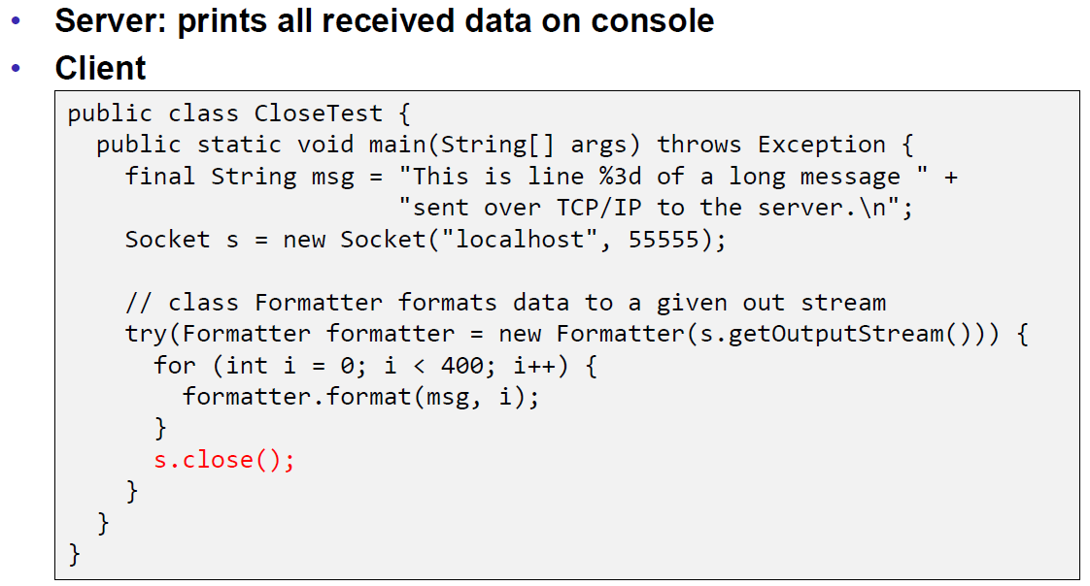

Problem: Some content of the formatter is not received by the server.

Solution: Flush the formatter before you close the socket, otherwise the buffer of the formatter won’t be sent.

### Example of a Compression Server

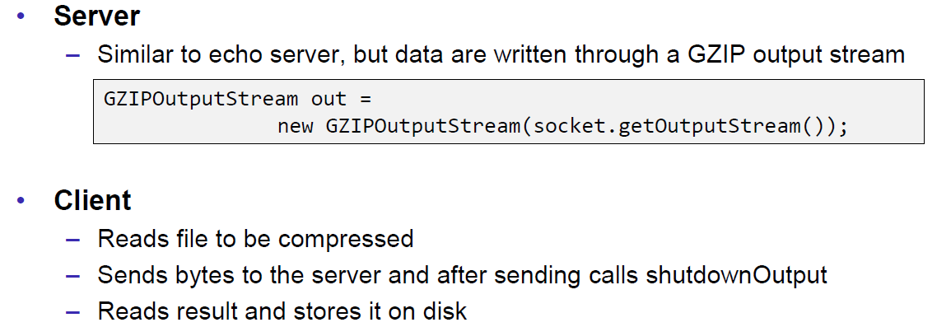

Problem: At some point, the server hangs up and doesn’t reply anymore.

Solution: Don’t send all content before you start reading. Otherwise you will fill up the outgoing (sending) cache of the server (because no one is reading it) and the write process of the server becomes blocking (this prevents a data loss because the outgoing buffer is full). A solution to this problem is to write and read block by block or to start the send process in a separate thread (Both happens in the client), so the client is able to immediately read the result and prevents a full sender buffer of the server.

## UDP Sockets

### UDP (User Datagram Protocol)

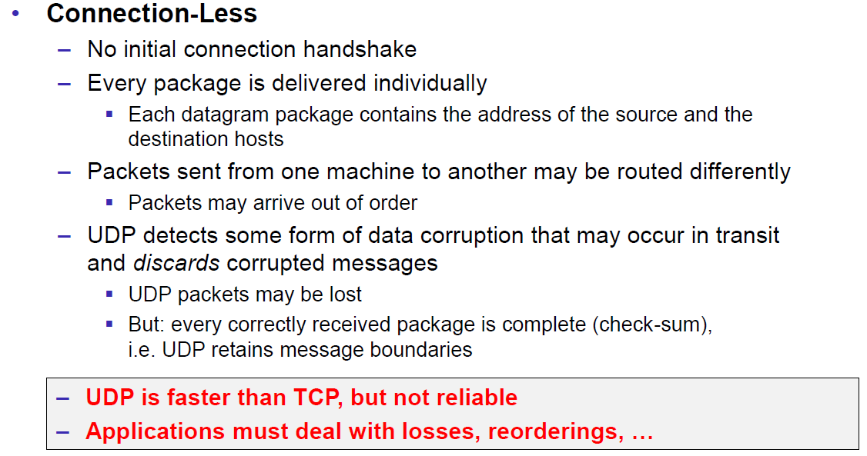

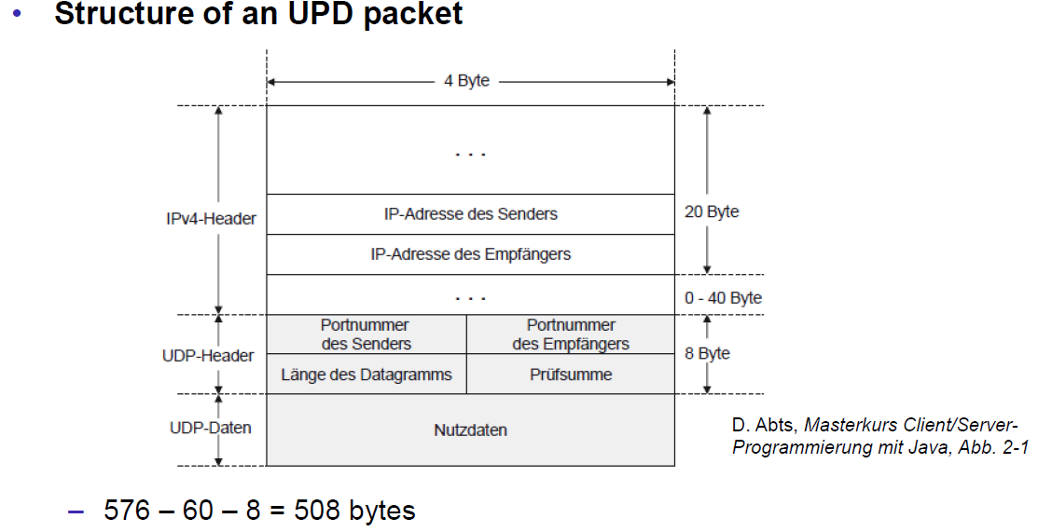

### Java Classes for Datagram

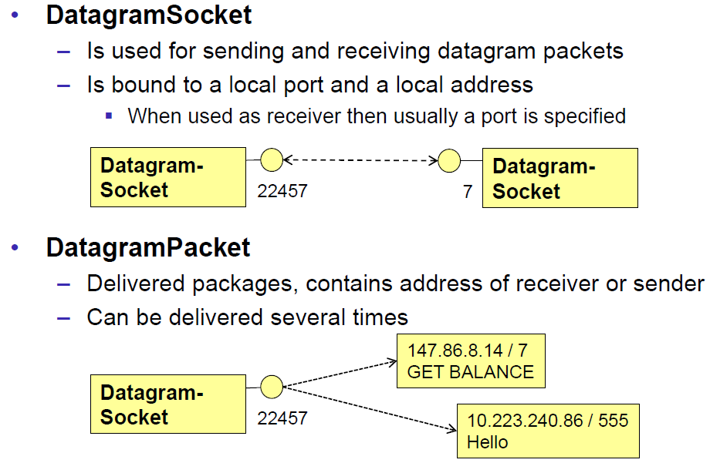

### DatagramSocket

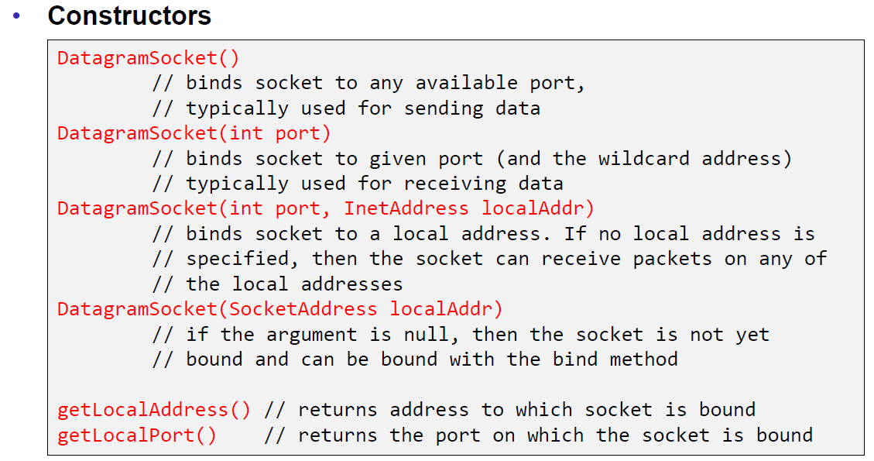

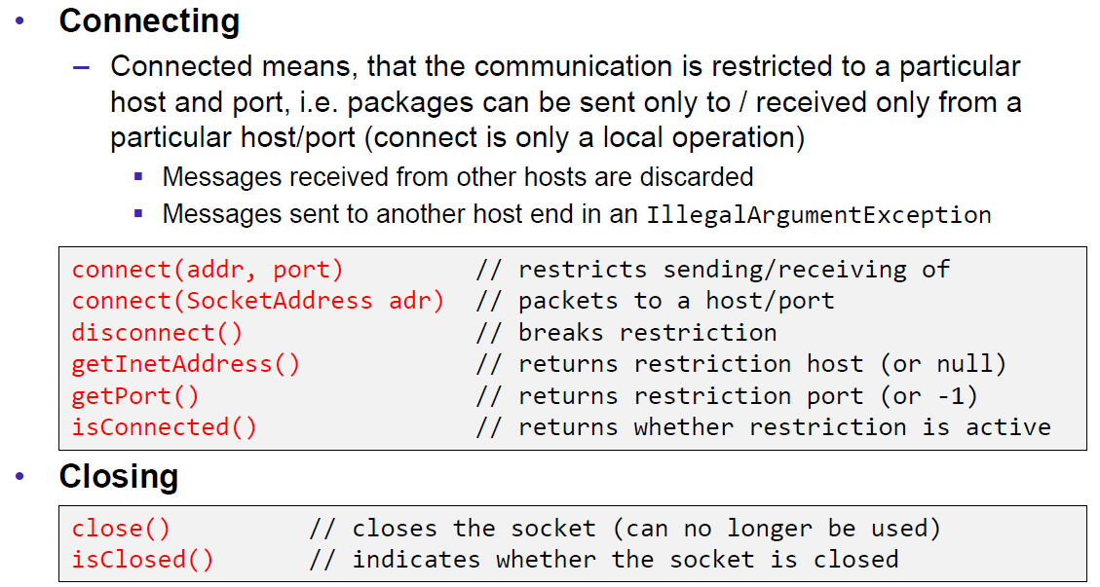

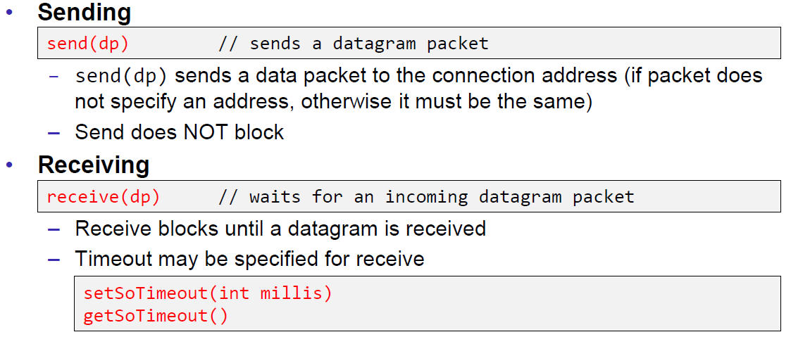

### DatagramPacket

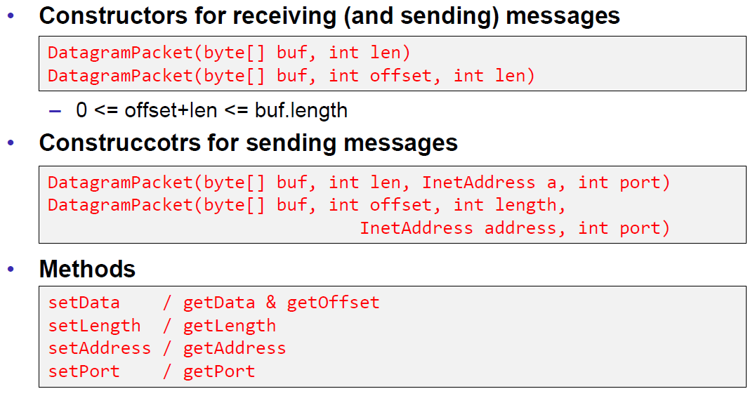

### Example of a UDP Server and Client

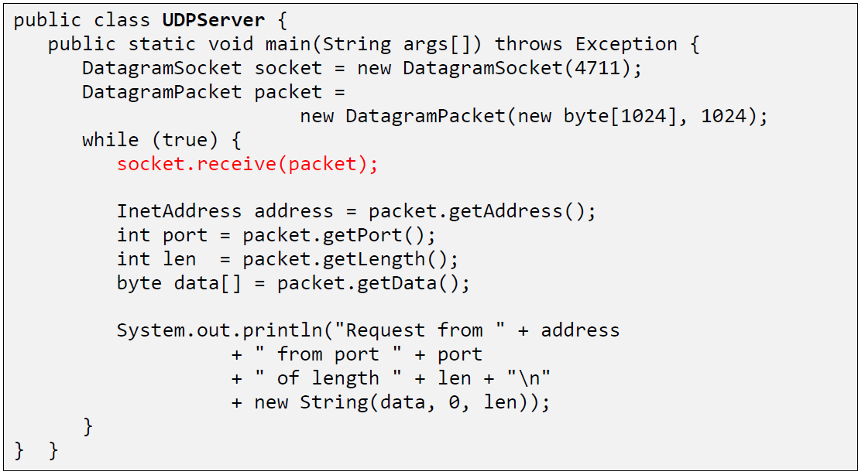

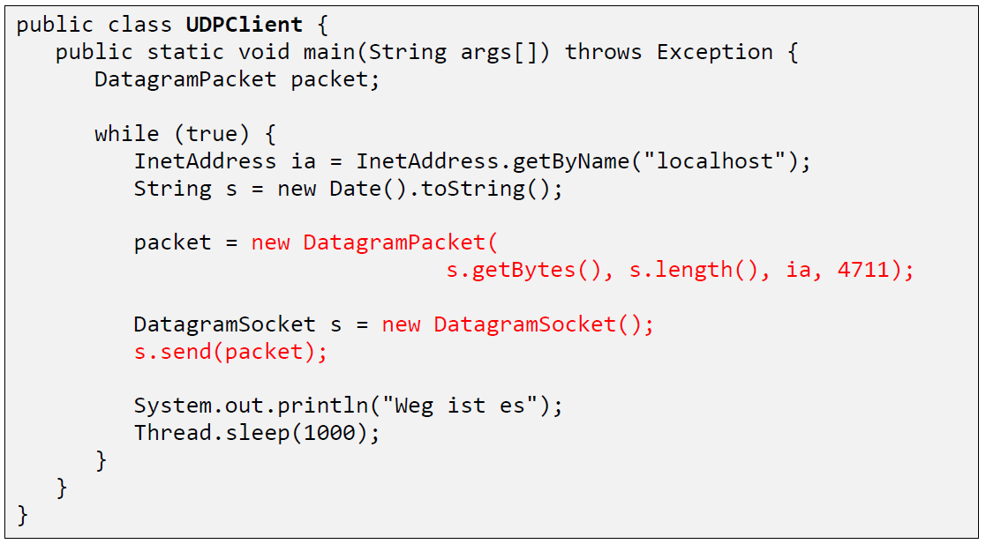

### UDP Implementation

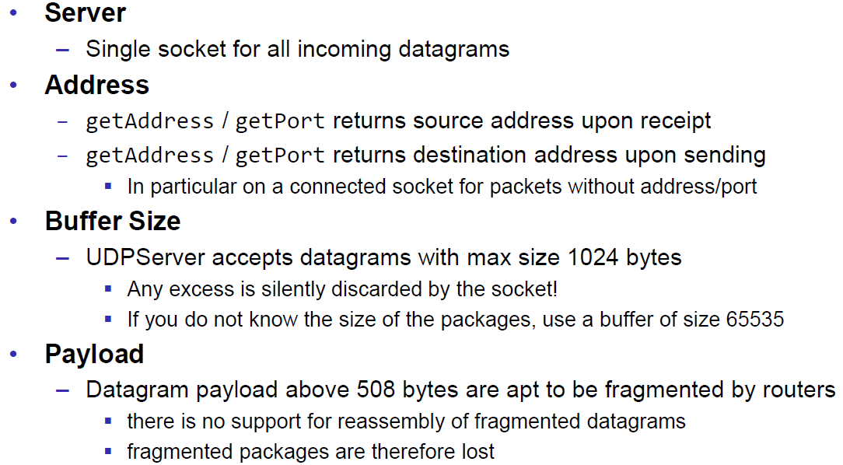

### Reliable UDP

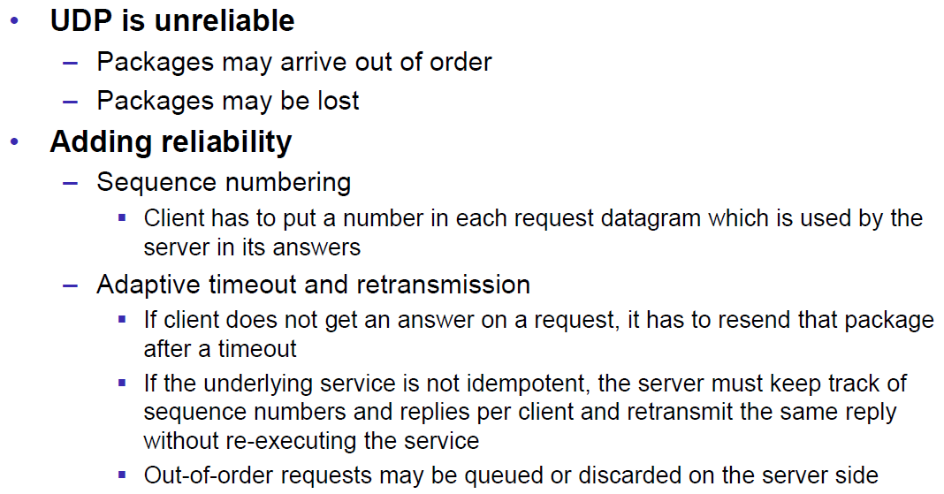

# Woche 3